

Common Security Module
Software Architecture Document

Common Security Module (CSM)
Integration Support Project

Version No: 0.3
Final as of 01-06-2004

Author : Vinay Kumar, Kunal Modi
Team : Architecture Team
Client : Nation Cancer Institute - Center for Bioinformatics,
National Institutes of Health,
US Department of Health and Human Services

Document Number : CSMSAD
Contract Number : 467-FZ-302102
© Copyright 2004 by Ekagra Software Technologies Ltd.
All rights reserved.

Document History

Document Location
Ensure that this document is current. Printed documents and locally copied files may become obsolete due to changes to the master document. The source of the document is located in NCI CVS at the following path security/phase2/doc.

Revision History
Version Number | Revision Date | Author | Summary of Changes
0.1 | 10-27-04 | Kunal Modi | Initial version
0.2 | 11-24-04 | Kunal Modi | Stage Revision
0.3 | 01-06-04 | Vinay Kumar, Kunal Modi, Eric Copen | Revision

Ekagra Internal Reviews
Name | Team/Role | Version and  Date Reviewed | Reviewer’s Signature
Kunal Modi | Author
Vinay Kumar | Author, Software Architect
Brian Husted | Software Architect
Kalpesh Patel | Program Manager

Client Reviews
Name | Team/Role | Version and  Date Reviewed | Reviewer Comments

Reference Documents
Document Name | Version
NCICB Common_Security_Vision.doc | http://ncicbintra.nci.nih.gov/ncicb_common/commonlfs/SECURITY_SCOPE_VISION_PHASE2
NCICB Security_Supplementary_Phase2.doc | http://ncicbintra.nci.nih.gov/ncicb_common/commonlfs/SECURITY_SUPPLEMENTARY_PHASE2

Table of Contents
1. Introduction 1
1.1. Overview 1
1.2. Purpose and Objective 1
1.3. Scope 1
1.4. Definitions, Acronyms, and Abbreviations 1
2. Architectural Representation 2
3. Architectural Goals and Constraints 2
4. Use-Case View 2
Actors 4
Use Case groups 4
Future Phase Use Cases 4
4.1. Use-Case Realizations 5
5. Logical View 6
5.1. Logical Model 6
5.1.1. security::CommonSecurityManager 8
5.1.2. security::SecurityServiceProvider 10
5.1.3. security::AuthenticationManager 11
5.1.4. security::AuthorizationManager 11
5.1.5. security::UserProvisioningManager 13
5.1.6. authentication::AuthenticationManagerFactory 16
5.1.7. authentication::CommonAuthenticationManager 16
5.1.8. authentication::CustomAuthenticationManager 17
5.1.9. handler::CSMCallbackHandler 18
5.1.10. loginmodules::RDBMSLoginModule 19
5.1.11. authorization::AuthorizationManagerFactory 20
5.1.12. domainobjects::Application 21
5.1.13. domainobjects::ApplicationContext 22
5.1.14. domainobjects::Group 24
5.1.15. domainobjects::GroupRoleContext 25
5.1.16. domainobjects::Privilege 26
5.1.17. domainobjects::ProtectionElement 27
5.1.18. domainobjects::ProtectionGroup 29
5.1.19. domainobjects::ProtectionGroupRoleContext 31
5.1.20. domainobjects::Role 32
5.1.21. domainobjects::User 34
5.1.22. domainobjects::UserProtectionElement 37
5.1.23. domainobjects::UserRoleContext 38
5.1.24. dao::AuthorizationDAOImpl 39
5.1.25. dao::AuthorizationDAOSessionFactory 44
5.1.26. dao::GroupSearchCriteria 44
5.1.27. dao::PrivilegeSearchCriteria 45
5.1.28. dao::ProtectionGroupSearchCriteria 45
5.1.29. dao::RoleSearchCriteria 46
5.1.30. dao::SearchCriteria 46
5.1.31. dao::UserSearchCriteria 46
5.1.32. dao::AuthorizationDAO 47
5.1.33. hibernate::HibernateSessionFactory 50
5.1.34. hibernate::ProtectionGroupProtectionElement 50
5.1.35. hibernate::RolePrivilege 51
5.1.36. hibernate::UserGroup 52
5.1.37. exceptions::CSDataAccessException 53
5.1.38. exceptions::CSException 54
5.1.39. exceptions::CSObjectNotFoundException 54
5.1.40. exceptions::CSMecurityException 55
5.1.41. exceptions::CSTransactionException 55
5.1.42. provisioning::UserProvisioningManagerImpl 56
5.1.43. system::ApplicationSessionFactory 60
5.1.44. util::ObjectSetUtil 61
6. Process View 62
7. Deployment View 63
8. Data View 63
8.1.1. APPLICATION 64
8.1.2. GROUPS 65
8.1.3. PRIVILEGE 66
8.1.4. PROTECTION_ELEMENT 66
8.1.5. PROTECTION_GROUP 67
8.1.6. PROTECTION_GROUP_PROTECTION_ELEMENT 68
8.1.7. ROLE 69
8.1.8. ROLE_PRIVILEGE 70
8.1.9. USER 71
8.1.10. USER_GROUP 72
8.1.11. USER_GROUP_ROLE_PROTECTION_GROUP 72
8.1.12. USER_PROTECTION_ELEMENT 74
9. Technology Stack 75

- Introduction

Overview

This Software Architecture Document provides software architecture and high level design for the new Common Security Module (CSM) system. This document will be used as a recommendation and guideline by the development team to develop detail design for the system. It emphasizes the architecturally significant parts of the design model.

Purpose and Objective

The purpose of this document is to provide high-level architectural guidelines for the security framework.
This document’s intended audience includes the CSM Program manager, the Security Working Group and the development team members of the task.

Scope

This document focuses on the first phase of the CSM task. The focus of the first phase is to implement the Authentication and Authorization Use Cases as well as the User Provisioning tool if time allows. The Service will be available as an API in this phase. Detailed design and implementation will not be addressed in this document and will be left to define for development team.

Definitions, Acronyms, and Abbreviations
For Definitions, Acronyms, and Abbreviations please refer to the following table:

Abbrevation | Description
SSO | Single Sign On. Using SSO a user has to sign on once and after that user can switch between applications without being challenged again until and unless the session expires.
Protected Element | Protected element is a data set that has a controlled access as per the roles and privileges. A protected element can be any object also. Basically it is a conceptual entity that an application will associate with any piece of data that it wants to protect.
Protection group | Used to group protected elements together so that all may be assigned to a Role/user at once. Also allows the Role/User to access future protected elements that do not exist yet.
Role | The role is to be seen in the context of an application and /or protection group. A role is assigned to user to grant them privileges on particular protection group.
Privilege | Privilege is a kind of operation that can be performed on any data.
User | The user is a user for an application or for a system or both.
Application | Any software or set of software's to achieve some business or technical goals.
Systems | Any module, an application or set of connected modules
Message | A message (text message) that flows between applications or systems
Encryption | A process by which any readable information becomes unreadable

Architectural Representation
Presented in this document is the high-level software architecture approach for a new eNotification system. This approach is represented through Use-Case, Process, Deployment, and Data Views.

Architectural Goals and Constraints
The standard hardware and software environment shall be used during the CSM task implementation. The CSM system is standardizing on the J2EE platform. The major technologies used are JBoss Application Server, Apache Struts Framework, Hibernate Persistence Framework, MySQL database etc. Both application and database servers will be running on the Solaris operating system. In addition standard J2EE framework services and common J2EE design patterns shall be used as a base for the J2EE development.

Use-Case View
CSM Use Cases can be grouped into multiple major sets based on actors and functionality. The below diagram illustrates the required use cases.

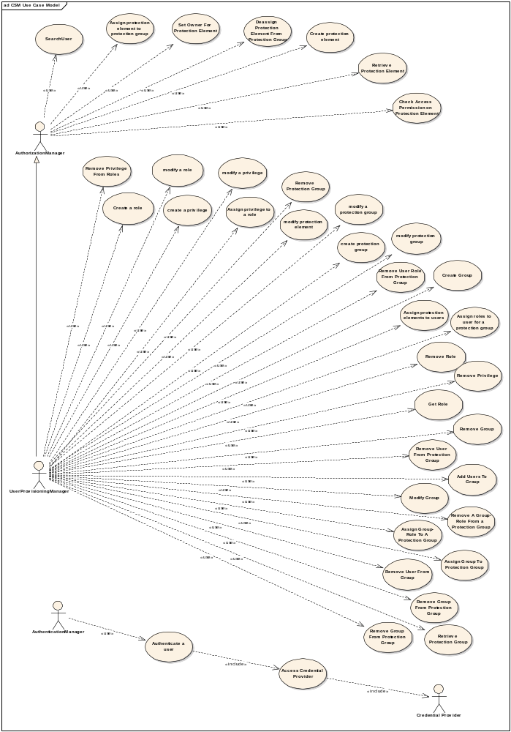

Actors

Authentication Manager – An actor who uses the Common Security Module application for the purpose of authenticating user credentials
Authorization Manager – An actor who uses the Common Security Module application for the purpose of authorizing the user actions on various protected resources
User Provisioning Manager – An actor who uses the uses the user provisioning tool to configure the authorization data in the common security module database. It extents the Authorization Manager
User – A user of the client application
System – The CSM Application on whole with hard worker
Credential Providers – The actual data stores where the user login credentials are stored and will be authenticated against

Use Case groups

Use Cases to be implemented in Current Phase:
Authentication - refers to the validation and verification of a user’s credentials.
- Reliably and securely determine access to an application
- System to system authentication

Authorization - grants access to various protection elements (methods, objects and data).
- Protect privileged resources from unauthorized users
- Associate user roles with distinctly defined privileges
- Ability to set access control for datasets

User Provisioning Tool – allows to configure the authorization data for the user in the schema
- Web enabled application
- Access to multiple user repositories
- Provide tools to add, modify, read or delete user authorization data

Logging – allows the tracking of user login as well as authorization actions at a central location

Future Phase Use Cases

Single Sign on - allows the seamless transfer of authentication credentials for user to system communication.
- Allows a user to navigate the trusted domain with a single ID
- Seamless transfer of authorization credentials from one system to another.
- Honoring of authentication and authorization among distributed applications

Message Level Security - provides secure messaging between applications.
- Encryption of private data elements
- Independent transport mechanism
- Support for workflow and messaging between applications
- Secure the messages between user to system
- Secure the messages between system to system

HIPPA Compliance
- Data that can identify a user must be protected
- Applications must be able to share confidential data

eAuthentication
- Federated identity
- External credential providers

Interoperability
- The security service architecture must provide the ability to interoperate with multiple software platforms

Use-Case Realizations

This section illustrates how the software works by providing realization of the use-cases selected for the first iteration and explains how the various design model elements contribute to their functionality.
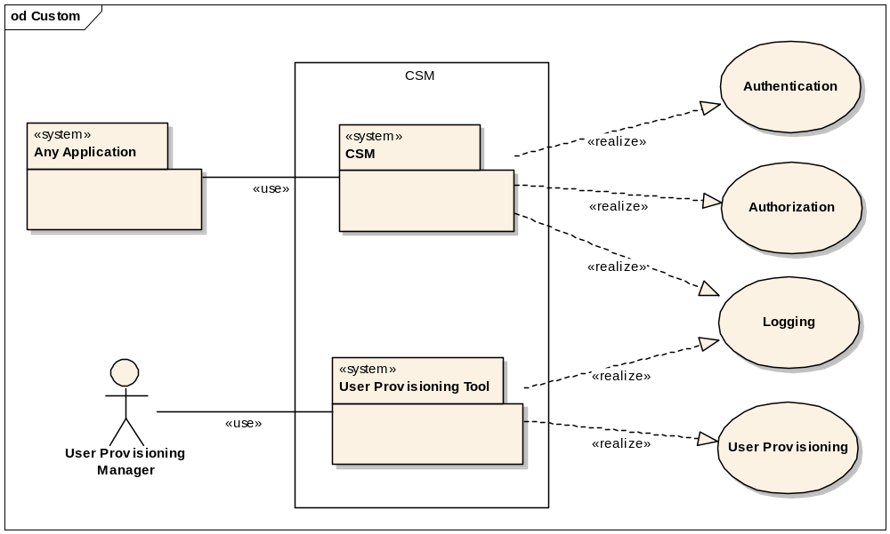
Use Case Realization View

The Authentication and Authorization Use Cases will be realized through the CSM library component. This component will be accessible only by the application with a specially defined role.
The User Provisioning Use Case will be realized through the User Provisioning Tool application. This will be a web application which will be accessible to the users with the role of User Provisioning Manager.
The Logging Use Cases will be realized by both the CSM library component and the User Provisioning Tool. It will track all the authentication and authorization activities for the CSM at the same time will log all the changes made to the authorization schema by the User Provisioning Manager.

Logical View
Logical View of the design model, such as its decomposition into subsystems and packages will be determined during development phase of the task.

Logical Model

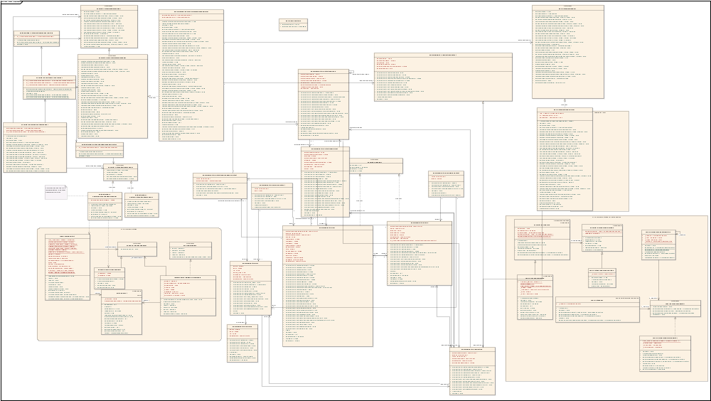

Figure 1 : Detail Class Diagram
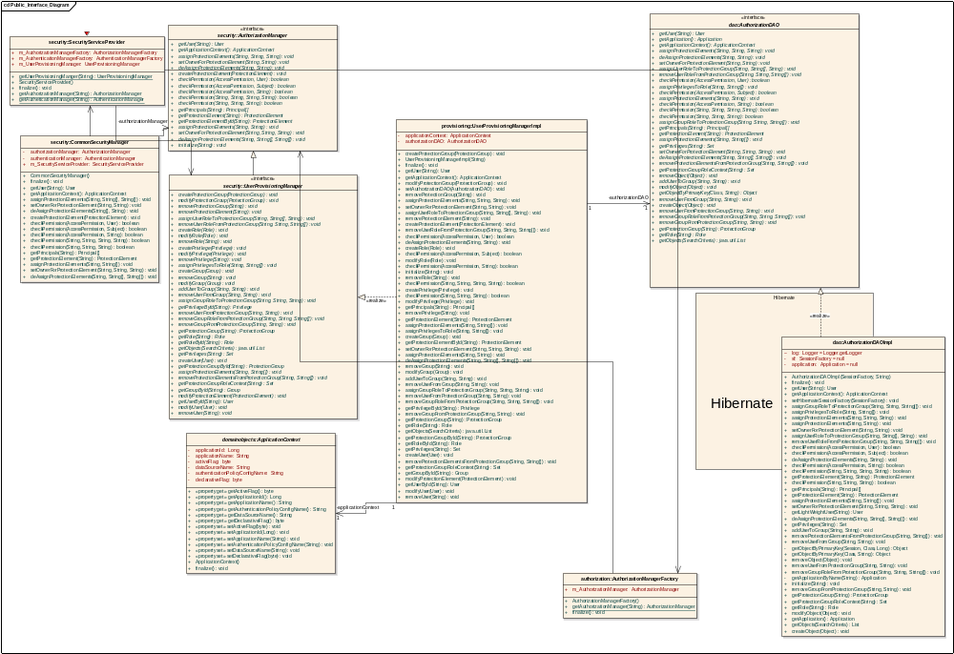
Figure 2 : Programming Interface Diagram
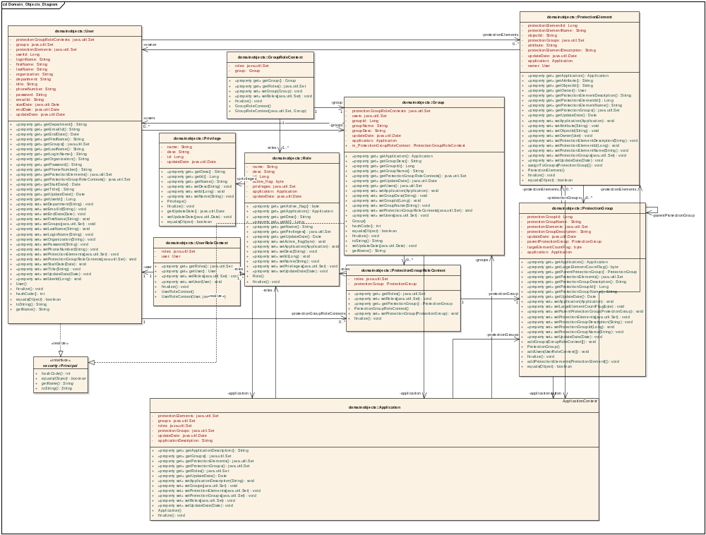
Figure 3 : Object Model Diagram

security::CommonSecurityManager
Type: public Class
Status: Proposed. Version 1.0. Phase 1.0.
Package: security
Details: Created on 11/2/2004 4:04:57 PM. Modified on 1/5/2005 11:54:48 AM.

The CommonSecurityManager will be used by client application. Programmers don't have to worry about the underlying implementation for authentication.
@created 16-Nov-2004 02:01:31 PM

Connections
- Association link to class SecurityServiceProvider
- Association link to interface AuthorizationManager
- Association link to interface AuthenticationManager

security::CommonSecurityManager Attributes
Attribute | Type | Notes
authorizationManager | private :  AuthorizationManager | authorizationManager is an instance of AuthorizationManager, whcih is used for runtime authorization needs.
authenticationManager | private :  AuthenticationManager | authenticationManager is of AuthenticationManager type , which is used to authnticate a user in context of an application.
m_SecurityServiceProvider | public :  SecurityServiceProvider

security::CommonSecurityManager Methods
Method | Type | Notes
CommonSecurityManager () | public:
finalize () | public: void
getUser (String) | public: User | param: loginName [ String - in ]  loginName
getApplicationContext () | public: ApplicationContext
assignProtectionElements (String, String[], String[]) | public: void | param: protectionGroupName [ String - in ]  param: protectionElementObjectName [ String[] - in ]  param: protectionElementAttributeName [ String[] - in ]  protectionElementAttributeName
setOwnerForProtectionElement (String, String) | public: void | param: protectionElementObjectName [ String - in ]  param: userName [ String - in ]  userName
deAssignProtectionElements (String[], String) | public: void | param: protectionElementObjectNames [ String[] - in ]  param: protectionGroupName [ String - in ]  protectionGroupName
createProtectionElement (ProtectionElement) | public: void | param: protectionElement [ ProtectionElement - in ]  protectionElement
checkPermission (AccessPermission, User) | public: boolean | param: permission [ AccessPermission - in ]  param: user [ User - in ]  user
checkPermission (AccessPermission, Subject) | public: boolean | param: permission [ AccessPermission - in ]  param: subject [ Subject - in ]  subject
checkPermission (AccessPermission, String) | public: boolean | param: permission [ AccessPermission - in ]  param: userName [ String - in ]  userName
checkPermission (String, String, String, String) | public: boolean | param: userName [ String - in ]  param: objectId [ String - in ]  param: attributeId [ String - in ]  param: privilegeName [ String - in ]  privilegeName
checkPermission (String, String, String) | public: boolean | param: userName [ String - in ]  param: objectId [ String - in ]  param: privilegeName [ String - in ]  privilegeName
getPrincipals (String) | public: Principal | param: userName [ String - in ]  userName
getProtectionElement (String) | public: ProtectionElement | param: objectId [ String - in ]  objectId  Returns the protection element for the passed object id
assignProtectionElements (String, String[]) | public: void | param: protectionGroupName [ String - in ]  param: protectionElementObjectNames [ String[] - in ]  protectionElementObjectNames
setOwnerForProtectionElement (String, String, String) | public: void | param: userName [ String - in ]  param: protectionElementObjectName [ String - in ]  param: protectionElementAttributeName [ String - in ]  protectionElementAttributeName
deAssignProtectionElements (String, String[], String[]) | public: void | param: protectionGroupName [ String - in ]  param: protectionElementObjectNames [ String[] - in ]  param: protectionElementAttributeNames [ String[] - in ]  protectionElementAttributeNames

security::SecurityServiceProvider
Type: public Class
Status: Proposed. Version 1.0. Phase 1.0.
Package: security
Details: Created on 11/9/2004 8:56:13 PM. Modified on 1/5/2005 11:54:49 AM.

This class gives the appropriate managers for a application. The three mnagers that it gives are AuthorizationManager,UserProvisioningManager and AuthenticationManager
@created 03-Dec-2004 1:17:51 AM

Connections
- Association link to interface UserProvisioningManager
- Association link to class AuthenticationManagerFactory<authentication>
- Association link to class AuthorizationManagerFactory<authorization>
- Association link from class CommonSecurityManager

security::SecurityServiceProvider Attributes
Attribute | Type | Notes
m_AuthorizationManagerFactory | public :  AuthorizationManagerFactory
m_AuthenticationManagerFactory | public :  AuthenticationManagerFactory
m_UserProvisioningManager | public :  UserProvisioningManager

security::SecurityServiceProvider Methods
Method | Type | Notes
getUserProvisioningManger (String) | public static: UserProvisioningManager | param: contextName [ String - in ]  contextName  This method will read a config file where name of the application context is there. It will make applicationcontext and keep it UserProvisioningManager
SecurityServiceProvider () | public:
finalize () | public: void
getAuthorizationManager (String) | public static: AuthorizationManager | param: applicationContextName [ String - in ]  applicationContextName
getAutheticationManager (String) | public static: AuthenticationManager | param: applicationContextName [ String - in ]  applicationContextName

security::AuthenticationManager
Type: public abstract «interface» Interface
Status: Proposed. Version 1.0. Phase 1.0.
Package: security
Details: Created on 12/2/2004 11:39:05 AM. Modified on 1/5/2005 11:54:48 AM.

@created 03-Dec-2004 1:17:47 AM

Connections
- Association link from class AuthenticationManagerFactory <authentication>
- Association link from class CommonSecurityManager
- Realize link from class CustomAuthenticationManager <authentication>
- Realize link from class CommonAuthenticationManager <authentication>

security::AuthenticationManager Interfaces
Method | Type | Notes
login (String, String) | public: boolean | param: password [ String - in ]  param: userName [ String - in ]  userName
initialize (String) | public: void | param: applicationContextName [ String - in ]  applicationContextName
getSubject () | public: Subject
setApplicationContextName (String) | public: void | param: applicationContextName [ String - in ]  applicationContextName
getApplicationContextName () | public: String

security::AuthorizationManager
Type: public abstract «interface» Interface
Status: Proposed. Version 1.0. Phase 1.0.
Package: security
Details: Created on 11/9/2004 9:13:53 PM. Modified on 1/5/2005 12:52:51 PM.

The AuthorizationManager interface facilitates with programatic authorization needs. This interfcae mainly deals with runtime authorization needs. Only one AuthorizationManager will exist for a application. In other words the AuthorizationManager exist in the context of an application.
@created 03-Dec-2004 1:17:48 AM

Connections
- Association link from class CommonSecurityManager
- Association link from class AuthorizationManagerFactory <authorization>
- Generalization link from interface UserProvisioningManager

security::AuthorizationManager Interfaces
Method | Type | Notes
getUser (String) | public: User | param: loginName [ String - in ]  loginName
getApplicationContext () | public: ApplicationContext
assignProtectionElements (String, String, String) | public: void | param: protectionGroupName [ String - in ]  param: protectionElementObjectId [ String - in ]  param: protectionElementAttributeName [ String - in ]  protectionElementAttributeName
setOwnerForProtectionElement (String, String) | public: void | param: protectionElementObjectName [ String - in ]  param: userName [ String - in ]  userName
deAssignProtectionElements (String, String) | public: void | param: protectionGroupName [ String - in ]  param: protectionElementObjectId [ String - in ]  protectionElementObjectId
createProtectionElement (ProtectionElement) | public: void | param: protectionElement [ ProtectionElement - in ]  protectionElement
checkPermission (AccessPermission, User) | public: boolean | param: permission [ AccessPermission - in ]  param: user [ User - in ]  user
checkPermission (AccessPermission, Subject) | public: boolean | param: permission [ AccessPermission - in ]  param: subject [ Subject - in ]  subject
checkPermission (AccessPermission, String) | public: boolean | param: permission [ AccessPermission - in ]  param: userName [ String - in ]  userName
checkPermission (String, String, String, String) | public: boolean | param: userName [ String - in ]  param: objectId [ String - in ]  param: attributeId [ String - in ]  param: privilegeName [ String - in ]  privilegeName
checkPermission (String, String, String) | public: boolean | param: userName [ String - in ]  param: objectId [ String - in ]  param: privilegeName [ String - in ]  privilegeName
getPrincipals (String) | public: Principal | param: userName [ String - in ]  userName
getProtectionElement (String) | public: ProtectionElement | param: objectId [ String - in ]  objectId  Returns the protection element for the passed object id
getProtectionElementById (String) | public: ProtectionElement | param: protectionElementId [ String - in ]  protectionElementId  Returns the protection element for the passed object id
assignProtectionElements (String, String) | public: void | param: protectionGroupName [ String - in ]  param: protectionElementObjectId [ String - in ]  At run time only one protectionElement can be assigned to a protection group
setOwnerForProtectionElement (String, String, String) | public: void | param: userName [ String - in ]  param: protectionElementObjectName [ String - in ]  param: protectionElementAttributeName [ String - in ]  protectionElementAttributeName
deAssignProtectionElements (String, String[], String[]) | public: void | param: protectionGroupName [ String - in ]  param: protectionElementObjectNames [ String[] - in ]  param: protectionElementAttributeNames [ String[] - in ]  protectionElementAttributeNames
initialize (String) | public: void | param: applicationContextName [ String - in ]  applicationContextName

security::UserProvisioningManager
Type: public abstract «interface» Interface
Extends: AuthorizationManager.
Status: Proposed. Version 1.0. Phase 1.0.
Package: security
Details: Created on 11/9/2004 1:57:33 PM. Modified on 1/5/2005 1:01:21 PM.

The UserProvisioningManager interface extends the AuthorizationManager interface and is used for user provisioning. The UserProvisioningManager exist in context of an application.
@created 03-Dec-2004 1:17:51 AM

Connections
- Association link from class SecurityServiceProvider
- Generalization link to interface AuthorizationManager
- Realize link from class UserProvisioningManagerImpl <provisioning>

security::UserProvisioningManager Interfaces
Method | Type | Notes
createProtectionGroup (ProtectionGroup) | public: void | param: protectionGroup [ ProtectionGroup - in ]  protectionGroup
modifyProtectionGroup (ProtectionGroup) | public: void | param: protectionGroup [ ProtectionGroup - in ]  protectionGroup
removeProtectionGroup (String) | public: void | param: protectionGroupId [ String - in ]  protectionGroupId
removeProtectionElement (String) | public: void | param: protectionElementId [ String - in ]  @param element
assignUserRoleToProtectionGroup (String, String[], String) | public: void | param: userId [ String - in ]  param: rolesId [ String[] - in ]  param: protectionGroupId [ String - in ]  protectionGroupId
removeUserRoleFromProtectionGroup (String, String, String[]) | public: void | param: protectionGroupId [ String - in ]  param: userId [ String - in ]  param: rolesId [ String[] - in ]  @param protectionGroupName  @param userName  @param roles
createRole (Role) | public: void | param: role [ Role - in ]  role
modifyRole (Role) | public: void | param: role [ Role - in ]  role
removeRole (String) | public: void | param: roleId [ String - in ]  roleId
createPrivilege (Privilege) | public: void | param: privilege [ Privilege - in ]  privilege
modifyPrivilege (Privilege) | public: void | param: privilege [ Privilege - in ]  privilege
removePrivilege (String) | public: void | param: privilegeId [ String - in ]  privilegeId
assignPrivilegesToRole (String, String[]) | public: void | param: roleId [ String - in ]  param: privilegeIds [ String[] - in ]  privilegeIds
createGroup (Group) | public: void | param: group [ Group - in ]  group
removeGroup (String) | public: void | param: groupId [ String - in ]  groupId
modifyGroup (Group) | public: void | param: group [ Group - in ]  group
addUserToGroup (String, String) | public: void | param: groupId [ String - in ]  param: userId [ String - in ]  userId
removeUserFromGroup (String, String) | public: void | param: groupId [ String - in ]  param: userId [ String - in ]  userId
assignGroupRoleToProtectionGroup (String, String, String) | public: void | param: protectionGroupId [ String - in ]  param: groupId [ String - in ]  param: rolesId[] [ String - in ]  @param rolesId
getPrivilegeById (String) | public: Privilege | param: privilegeId [ String - in ]  privilegeId  Returns the privilege for the passed name privilege id
removeUserFromProtectionGroup (String, String) | public: void | param: protectionGroupId [ String - in ]  param: userId [ String - in ]  userId  This method removes the user from a protection group irrespective of all the roles
removeGroupRoleFromProtectionGroup (String, String, String[]) | public: void | param: protectionGroupId [ String - in ]  param: groupId [ String - in ]  param: roleId [ String[] - in ]  roleId
removeGroupFromProtectionGroup (String, String) | public: void | param: protectionGroupId [ String - in ]  param: groupId [ String - in ]  groupId
getProtectionGroup (String) | public: ProtectionGroup | param: protectionGroupName [ String - in ]  protectionGroupName
getRole (String) | public: Role | param: roleName [ String - in ]  roleName
getRoleById (String) | public: Role | param: roleId [ String - in ]  roleId
getObjects (SearchCriteria) | public: java.util.List | param: searchCriteria [ SearchCriteria - in ]  @param serachCriteria
getPrivileges (String) | public: Set | param: roleId [ String - in ]  roleId
createUser (User) | public: void | param: user [ User - in ]
getProtectionGroupById (String) | public: ProtectionGroup | param: protectionGroupId [ String - in ]
assignProtectionElements (String, String[]) | public: void | param: protectionGroupId [ String - in ]  param: protectionElementIds [ String[] - in ]
removeProtectionElementsFromProtectionGroup (String, String[]) | public: void | param: protectionGroupId [ String - in ]  param: protectionLementIds [ String[] - in ]
getProtectionGroupRoleContext (String) | public: Set | param: userId [ String - in ]
getGroupById (String) | public: Group | param: groupId [ String - in ]  groupId  Returns the Group for the passed name group id
modifyProtectionElement (ProtectionElement) | public: void | param: protectionElement [ ProtectionElement - in ]
getUserById (String) | public: User | param: userId [ String - in ]
modifyUser (User) | public: void | param: user [ User - in ]
removeUser (String) | public: void | param: userId [ String - in ]

authentication::AuthenticationManagerFactory
Type: public Class
Status: Proposed. Version 1.0. Phase 1.0.
Package: authentication
Details: Created on 11/2/2004 3:06:39 PM. Modified on 1/5/2005 11:54:49 AM.

AuthenticationServiceFactory Object will read a config file and accordingly get the appropriate implmentation for authentication. It returrns the AuthenticationService, which is an abstract class.
@created 03-Dec-2004 1:17:47 AM

Connections
- Association link from class SecurityServiceProvider <security>
- Association link to interface AuthenticationManager<security>

authentication::AuthenticationManagerFactory Attributes
Attribute | Type | Notes
m_AuthenticationManager | public :  AuthenticationManager

authentication::AuthenticationManagerFactory Methods
Method | Type | Notes
AuthenticationManagerFactory () | public:
getAuthenticationManager (String) | public static: AuthenticationManager | param: applicationName [ String - in ]  applicationName
finalize () | public: void

authentication::CommonAuthenticationManager
Type: public Class
Implements: AuthenticationManager.
Status: Proposed. Version 1.0. Phase 1.0.
Package: authentication
Details: Created on 11/2/2004 1:47:15 PM. Modified on 1/5/2005 11:54:49 AM.

@created 03-Dec-2004 1:17:48 AM

Connections
- Dependency link to class LoginContext<login>
- Dependency link to class CSMCallbackHandler<handler>
- Realize link to interface AuthenticationManager<security>

authentication::CommonAuthenticationManager Attributes
Attribute | Type | Notes
applicationContextName | private :  String | It is the name of the applicationContext by which an application is known.

authentication::CommonAuthenticationManager Methods
Method | Type | Notes
CommonAuthenticationManager () | public:
login (String, String) | public: boolean | param: password [ String - in ]  param: userName [ String - in ]  userName
finalize () | public: void
initialize (String) | public: void | param: applicationContext [ String - in ]  applicationContext  initialize the applicationContext with the value passed as parameter
getAuthenticatedObject () | public: Subject
getSubject () | public: Subject
setApplicationContextName (String) | public: void | param: applicationContextName [ String - in ]  applicationContextName
getApplicationContextName () | public: String

authentication::CustomAuthenticationManager
Type: public Class
Implements: AuthenticationManager.
Status: Proposed. Version 1.0. Phase 1.0.
Package: authentication
Details: Created on 11/2/2004 2:45:06 PM. Modified on 1/5/2005 11:54:49 AM.

This is the class that can be implemented by any application, if they choose not to use CommonAuthenticationServie implementation.
@created 03-Dec-2004 1:17:49 AM

Connections
- Realize link to interface AuthenticationManager<security>

authentication::CustomAuthenticationManager Methods
Method | Type | Notes
CustomAuthenticationManager () | public:
login (String, String) | public: boolean | param: password [ String - in ]  param: userName [ String - in ]  userName
finalize () | public: void
initialize (String) | public: void | param: applicationContext [ String - in ]  applicationContext  does nothing
getAuthenticatedObject () | public: Subject
getSubject () | public: Subject
setApplicationContextName (String) | public: void | param: applicationContextName [ String - in ]  applicationContextName
getApplicationContextName () | public: String

handler::CSMCallbackHandler
Type: public Class
Extends: CallbackHandler.
Status: Proposed. Version 1.0. Phase 1.0.
Package: handler
Details: Created on 11/4/2004 12:27:57 PM. Modified on 1/5/2005 12:56:52 PM.

@created 05-Jan-2005 11:53:29 AM

Connections
- Dependency link from class CommonAuthenticationManager <authentication>
- Generalization link to interface CallbackHandler<callback>

handler::CSMCallbackHandler Attributes
Attribute | Type | Notes
_userName | private :  String
_password | private :  String

handler::CSMCallbackHandler Methods
Method | Type | Notes
CSMCallbackHandler (String, String) | public: | param: password [ String - in ]  param: userName [ String - in ]  userName
CSMCallbackHandler () | public:
finalize () | public: void
handle (Callback[]) | public: void | param: callbacks [ Callback[] - in ]  callbacks
handle (Callback) | public: void | param: acallback[] [ Callback - in ]  @param acallback[]

loginmodules::RDBMSLoginModule
Type: public Class
Implements: LoginModule.
Status: Proposed. Version 1.0. Phase 1.0.
Package: loginmodules
Details: Created on 11/8/2004 12:46:50 PM. Modified on 1/5/2005 12:56:52 PM. Author: Kunal Modi (Ekagra Software Technologies Ltd.) This class is the implementation of the LoginModule interface and is used to connect to RDBMS to authenticate the user using the passed credentials. The class is initialized and invoked by the JAAS based on

@created 05-Jan-2005 11:53:31 AM

Connections
- Association link to interface CallbackHandler<callback>
- Association link to class Subject<auth>
- Realize link to interface LoginModule<spi>

loginmodules::RDBMSLoginModule Attributes
Attribute | Type | Notes
_subject | private :  Subject
_callbackHandler | private :  CallbackHandler
_sharedState | private :  Map
_options | private :  Map
_userID | private :  String
_password | private :  char
_loginOK | private :  boolean | Initial Value: false;
_commitOK | private :  boolean | Initial Value: false;

loginmodules::RDBMSLoginModule Methods
Method | Type | Notes
initialize (Subject, CallbackHandler, Map, Map) | public: void | param: subject [ Subject - in ]  param: callbackHandler [ CallbackHandler - in ]  param: sharedState [ Map - in ]  param: options [ Map - in ]  options  @see javax.security.auth.spi.LoginModule#initialize(javax.security.auth.Subject, javax.security.auth.callback.CallbackHandler, java.util.Map, java.util.Map)
RDBMSLoginModule () | public:
finalize () | public: void
login () | public: boolean | retrieves the user credentials from the CallBacks and tries to validate them against the database. It retrieves userID and password from the CallbackHandler. It uses helper class to perform the actual DBMS operations and retrieve the user record. This method returns a true if the user authentication was sucessful else it throws a Login Exception.  @see javax.security.auth.spi.LoginModule#login()
commit () | public: boolean | @see javax.security.auth.spi.LoginModule#commit()
abort () | public: boolean | @see javax.security.auth.spi.LoginModule#abort()
logout () | public: boolean | @see javax.security.auth.spi.LoginModule#logout()
validate (String, char[]) | private: boolean | param: user [ String - in ]  the user entered user name provided by the calling application  param: password [ char[] - in ]  the user entered password provided by the calling application  This is an internal method which invokes the helper method from the RDBMSHelper class. It returns TRUE is the authentication is sucessful.  @return TRUE if the authentication was sucessful using the provided user credentials and FALSE if the authentication fails

authorization::AuthorizationManagerFactory
Type: public Class
Status: Proposed. Version 1.0. Phase 1.0.
Package: authorization
Details: Created on 12/2/2004 12:18:14 PM. Modified on 1/5/2005 11:54:50 AM.

@created 03-Dec-2004 1:17:48 AM

Connections
- Association link from class SecurityServiceProvider <security>
- Association link to interface AuthorizationManager<security>

authorization::AuthorizationManagerFactory Attributes
Attribute | Type | Notes
m_AuthorizationManager | public :  AuthorizationManager

authorization::AuthorizationManagerFactory Methods
Method | Type | Notes
AuthorizationManagerFactory () | public:
getAuthorizationManager (String) | public static: AuthorizationManager | param: applicationContextName [ String - in ]  applicationContextName
finalize () | public: void

domainobjects::Application
Type: public Class
Extends: ApplicationContext.
Status: Proposed. Version 1.0. Phase 1.0.
Package: domainobjects
Details: Created on 11/17/2004 3:11:13 PM. Modified on 1/5/2005 11:54:53 AM.

@created 17-Nov-2004 3:19:57 PM

Connections
- Association link from class AuthorizationDAOImpl <dao>
- Association link from class ProtectionElement
- Association link from class ProtectionGroup
- Association link from class Role
- Association link from class Group
- Association link to class ProtectionGroup
- Association link to class Role
- Association link to class Group
- Association link to class ProtectionElement
- Generalization link to class ApplicationContext

domainobjects::Application Attributes
Attribute | Type | Notes
protectionElements | private :  java.util.Set | The collection of protection elements which belong to this application
groups | private :  java.util.Set | The collection of groups which belong to this application
roles | private :  java.util.Set | The collection of roles which belong to this application
protectionGroups | private :  java.util.Set | The collection of protection groups which belong to this application
updateDate | private :  java.util.Date | The date when the data for this application was last modified
applicationDescription | private :  String | The brief description of the application

domainobjects::Application Methods
Method | Type | Notes
getApplicationDescription () | «property get»  public: String | The brief description of the application
getGroups () | «property get»  public: java.util.Set | The collection of groups which belong to this application
getProtectionElements () | «property get»  public: java.util.Set | The collection of protection elements which belong to this application
getProtectionGroups () | «property get»  public: java.util.Set | The collection of protection groups which belong to this application
getRoles () | «property get»  public: java.util.Set | The collection of roles which belong to this application
getUpdateDate () | «property get»  public: Date | The date when the data for this application was last modified
setApplicationDescription (String) | «property set»  public: void | param: newVal [ String - in ]  newVal  The brief description of the application
setGroups (java.util.Set) | «property set»  public: void | param: newVal [ java.util.Set - in ]  newVal  The collection of groups which belong to this application
setProtectionElements (java.util.Set) | «property set»  public: void | param: newVal [ java.util.Set - in ]  newVal  The collection of protection elements which belong to this application
setProtectionGroups (java.util.Set) | «property set»  public: void | param: newVal [ java.util.Set - in ]  newVal  The collection of protection groups which belong to this application
setRoles (java.util.Set) | «property set»  public: void | param: newVal [ java.util.Set - in ]  newVal  The collection of roles which belong to this application
setUpdateDate (Date) | «property set»  public: void | param: newVal [ Date - in ]  newVal  The date when the data for this application was last modified
Application () | public:
finalize () | public: void

domainobjects::ApplicationContext
Type: public abstract Class
Status: Proposed. Version 1.0. Phase 1.0.
Package: domainobjects
Details: Created on 11/2/2004 4:31:10 PM. Modified on 1/5/2005 11:54:51 AM.

Application Context is the represntative of the application. It holds method to retrieve all the object like protection groups, protection elements, roles etc that belong to that application.
@created 03-Dec-2004 1:17:47 AM

Connections
- Association link from class UserProvisioningManagerImpl <provisioning>
- Generalization link from class Application

domainobjects::ApplicationContext Attributes
Attribute | Type | Notes
applicationId | private :  Long | It is the unique id for the application in the database.
applicationName | private :  String | The name of the application. The saem name is used for applicationContextName.
activeFlag | private :  byte | This attributes indicates if the application is active or not.
dataSourceName | private :  String | This is the name of the data source for authorization data. This is the JNDI name for the data source for this application.
authenticationPolicyConfigName | private :  String | This name represent the the name that should be used to get all the configuration for authentication for this application.
declarativeFlag | private :  byte | Indicate whether the application uses declarative security or not

domainobjects::ApplicationContext Methods
Method | Type | Notes
getActiveFlag () | «property get»  public: byte | This attributes indicates if the application is active or not.
getApplicationId () | «property get»  public: Long | It is the unique id for the application in the database.
getApplicationName () | «property get»  public: String | The name of the application. The saem name is used for applicationContextName.
getAuthenticationPolicyConfigName () | «property get»  public: String | This name represent the the name that should be used to get all the configuration for authentication for this application.
getDataSourceName () | «property get»  public: String | This is the name of the data source for authorization data. This is the JNDI name for the data source for this application.
getDeclarativeFlag () | «property get»  public: byte | Indicate whether the application uses declarative security or not
setActiveFlag (byte) | «property set»  public: void | param: newVal [ byte - in ]  newVal  This attributes indicates if the application is active or not.
setApplicationId (Long) | «property set»  public: void | param: newVal [ Long - in ]  newVal  It is the unique id for the application in the database.
setApplicationName (String) | «property set»  public: void | param: newVal [ String - in ]  newVal  The name of the application. The saem name is used for applicationContextName.
setAuthenticationPolicyConfigName (String) | «property set»  public: void | param: newVal [ String - in ]  newVal  This name represent the the name that should be used to get all the configuration for authentication for this application.
setDataSourceName (String) | «property set»  public: void | param: newVal [ String - in ]  newVal  This is the name of the data source for authorization data. This is the JNDI name for the data source for this application.
setDeclarativeFlag (byte) | «property set»  public: void | param: newVal [ byte - in ]  newVal  Indicate whether the application uses declarative security or not
ApplicationContext () | public:
finalize () | public: void

domainobjects::Group
Type: public Class
Implements: Principal.
Status: Proposed. Version 1.0. Phase 1.0.
Package: domainobjects
Details: Created on 11/8/2004 1:43:32 PM. Modified on 1/5/2005 11:54:52 AM.

A Group is a logical collection of users. A group belongs to an application.
@created 03-Dec-2004 1:17:49 AM

Connections
- Association link to class Application
- Association link to class ProtectionGroupRoleContext
- Association link to class User
- Association link from class User
- Association link from class GroupRoleContext
- Association link from class Application
- Realize link to interface Principal<security>

domainobjects::Group Attributes
Attribute | Type | Notes
protectionGroupRoleContexts | private :  java.util.Set | This is the collection of ProtectionGroupRoleContext objects indicating the access of this group on the protection groups with respect to roles.
users | private :  java.util.Set | A collection of User objects. Indicates which users belongs to this group.
groupId | private :  Long | It is the unique id by which it is identified within an application.
groupName | private :  String | It is the logical name for the group.
groupDesc | private :  String | This is the brief description of the group.
updateDate | private :  java.util.Date | The date when the group information was updated
application | private :  Application | The application to which the following group belongs
m_ProtectionGroupRoleContext | public :  ProtectionGroupRoleContext

domainobjects::Group Methods
Method | Type | Notes
getApplication () | «property get»  public: Application | The application to which the following group belongs
getGroupDesc () | «property get»  public: String | This is the brief description of the group.
getGroupId () | «property get»  public: Long | It is the unique id by which it is identified within an application.
getGroupName () | «property get»  public: String | It is the logical name for the group.
getProtectionGroupRoleContexts () | «property get»  public: java.util.Set | This is the collection of ProtectionGroupRoleContext objects indicating the access of this group on the protection groups with respect to roles.
getUpdateDate () | «property get»  public: java.util.Date | The date when the group information was updated
getUsers () | «property get»  public: java.util.Set | A collection of User objects. Indicates which users belongs to this group.
setApplication (Application) | «property set»  public: void | param: newVal [ Application - in ]  newVal  The application to which the following group belongs
setGroupDesc (String) | «property set»  public: void | param: newVal [ String - in ]  newVal  This is the brief description of the group.
setGroupId (Long) | «property set»  public: void | param: newVal [ Long - in ]  newVal  It is the unique id by which it is identified within an application.
setGroupName (String) | «property set»  public: void | param: newVal [ String - in ]  newVal  It is the logical name for the group.
setProtectionGroupRoleContexts (java.util.Set) | «property set»  public: void | param: newVal [ java.util.Set - in ]  newVal  This is the collection of ProtectionGroupRoleContext objects indicating the access of this group on the protection groups with respect to roles.
setUsers (java.util.Set) | «property set»  public: void | param: newVal [ java.util.Set - in ]  newVal  A collection of User objects. Indicates which users belongs to this group.
Group () | public:
hashCode () | public: int
equals (Object) | public: boolean | param: obj [ Object - in ]  obj
finalize () | public: void
toString () | public: String
setUpdateDate (java.util.Date) | public: void | param: newVal [ java.util.Date - in ]  newVal  The date when the group information was updated
getName () | public: String

domainobjects::GroupRoleContext
Type: public Class
Status: Proposed. Version 1.0. Phase 1.0.
Package: domainobjects
Details: Created on 11/9/2004 12:06:31 PM. Modified on 1/5/2005 11:54:53 AM.

It is class which hold the roles which are assumed by a particular group in context of a protection group.
@created 03-Dec-2004 1:17:49 AM

Connections
- Association link to class Group
- Association link to class Role

domainobjects::GroupRoleContext Attributes
Attribute | Type | Notes
roles | private :  java.util.Set | The collection of roles which the group can assume in context of a protection group
group | private :  Group | The group object of the group which assumes the roles in context of a protection group

domainobjects::GroupRoleContext Methods
Method | Type | Notes
getGroup () | «property get»  public: Group | The group object of the group which assumes the roles in context of a protection group
getRoles () | «property get»  public: java.util.Set | The collection of roles which the group can assume in context of a protection group
setGroup (Group) | «property set»  public: void | param: newVal [ Group - in ]  newVal  The group object of the group which assumes the roles in context of a protection group
setRoles (java.util.Set) | «property set»  public: void | param: newVal [ java.util.Set - in ]  newVal  The collection of roles which the group can assume in context of a protection group
finalize () | public: void
GroupRoleContext () | public:
GroupRoleContext (java.util.Set, Group) | public: | param: roles [ java.util.Set - in ]  param: member [ Group - in ]  member

domainobjects::Privilege
Type: public Class
Status: Proposed. Version 1.0. Phase 1.0.
Package: domainobjects
Details: Created on 11/8/2004 1:59:36 PM. Modified on 1/5/2005 12:56:52 PM.

This class is used to define the operations and different access levels which can be associated with a user. e.g "Create", "Read", "Update", "Delete" etc..
@created 03-Dec-2004 1:17:50 AM

Connections
- Association link from class Role

domainobjects::Privilege Attributes
Attribute | Type | Notes
name | private :  String | This is the name of the privilege.
desc | private :  String | It gives the brief description about the privilege.
id | private :  Long | It is the unique id by for this privilege.
updateDate | private :  java.util.Date

domainobjects::Privilege Methods
Method | Type | Notes
getDesc () | «property get»  public: String | It gives the brief description about the privilege.
getId () | «property get»  public: Long | It is the unique id by for this privilege.
getName () | «property get»  public: String | This is the name of the privilege.
setDesc (String) | «property set»  public: void | param: newVal [ String - in ]  newVal  It gives the brief description about the privilege.
setId (Long) | «property set»  public: void | param: newVal [ Long - in ]  newVal  It is the unique id by for this privilege.
setName (String) | «property set»  public: void | param: newVal [ String - in ]  newVal  This is the name of the privilege.
Privilege () | public:
finalize () | public: void
getUpdateDate () | public: java.util.Date | The date when the privilege information was updated
setUpdateDate (java.util.Date) | public: void | param: newVal [ java.util.Date - in ]  The date when the privilege information was updated
equals (Object) | public: boolean | param: obj [ Object - in ]  obj

domainobjects::ProtectionElement
Type: public Class
Status: Proposed. Version 1.0. Phase 1.0.
Package: domainobjects
Details: Created on 11/9/2004 10:03:58 AM. Modified on 1/5/2005 12:59:22 PM.

A ProtectionElement is a any resource that is a candidate for to be protected. This way the access to different part of the data can be restricted.
@created 03-Dec-2004 1:17:50 AM

Connections
- Association link to class Application
- Association link to class User
- Association link from class User
- Association link to class ProtectionGroup
- Association link from class ProtectionGroup
- Association link from class Application

domainobjects::ProtectionElement Attributes
Attribute | Type | Notes
protectionElementId | private :  Long | It is the unique id by which it is identified in an application.
protectionElementName | private :  String | It is the name of the protection element
objectId | private :  String | It is the attribute of the object which is to be protected. It along with the attribute forms the unique key which can identify the protection element
protectionGroups | private :  java.util.Set | A collection of protection groups that this protection element belongs to.
attribute | private :  String | It is the attribute of the object which is to be protected. It along with the object id forms the unique key which can identify the protection element
protectionElementDescription | private :  String | A brief descrition of the protection element
updateDate | private :  java.util.Date | The date when the data for the protection element was updated
application | private :  Application | The application to which the protection element belongs
owner | private :  User | The user which owns the protection element. It will be populated only if the protection element was created at run time by the user

domainobjects::ProtectionElement Methods
Method | Type | Notes
getApplication () | «property get»  public: Application | The application to which the protection element belongs
getAttribute () | «property get»  public: String | It is the attribute of the object which is to be protected. It along with the object id forms the unique key which can identify the protection element
getObjectId () | «property get»  public: String | It is the attribute of the object which is to be protected. It along with the attribute forms the unique key which can identify the protection element
getOwner () | «property get»  public: User | The user which owns the protection element. It will be populated only if the protection element was created at run time by the user
getProtectionElementDescription () | «property get»  public: String | A brief descrition of the protection element
getProtectionElementId () | «property get»  public: Long | It is the unique id by which it is identified in an application.
getProtectionElementName () | «property get»  public: String | It is the name of the protection element
getProtectionGroups () | «property get»  public: java.util.Set | A collection of protection groups that this protection element belongs to.
getUpdateDate () | «property get»  public: Date | The date when the data for the protection element was updated
setApplication (Application) | «property set»  public: void | param: newVal [ Application - in ]  newVal  The application to which the protection element belongs
setAttribute (String) | «property set»  public: void | param: newVal [ String - in ]  newVal  It is the attribute of the object which is to be protected. It along with the object id forms the unique key which can identify the protection element
setObjectId (String) | «property set»  public: void | param: newVal [ String - in ]  newVal  It is the attribute of the object which is to be protected. It along with the attribute forms the unique key which can identify the protection element
setOwner (User) | «property set»  public: void | param: newVal [ User - in ]  newVal  The user which owns the protection element. It will be populated only if the protection element was created at run time by the user
setProtectionElementDescription (String) | «property set»  public: void | param: newVal [ String - in ]  newVal  A brief descrition of the protection element
setProtectionElementId (Long) | «property set»  public: void | param: newVal [ Long - in ]  newVal  It is the unique id by which it is identified in an application.
setProtectionElementName (String) | «property set»  public: void | param: newVal [ String - in ]  newVal  It is the name of the protection element
setProtectionGroups (java.util.Set) | «property set»  public: void | param: newVal [ java.util.Set - in ]  newVal  A collection of protection groups that this protection element belongs to.
setUpdateDate (Date) | «property set»  public: void | param: newVal [ Date - in ]  newVal  The date when the data for the protection element was updated
assignToGroups (ProtectionGroup[]) | public: void | param: protectionGroups [ ProtectionGroup[] - in ]  protectionGroups
ProtectionElement () | public:
finalize () | public: void
equals (Object) | public: boolean | param: obj [ Object - in ]  obj

domainobjects::ProtectionGroup
Type: public Class
Status: Proposed. Version 1.0. Phase 1.0.
Package: domainobjects
Details: Created on 11/9/2004 9:37:58 AM. Modified on 1/5/2005 12:59:22 PM.

This class represents a Protection Group. It is nothing but a collection of protection elements. A user or a user-group can assume various roles on a protection group
@created 03-Dec-2004 1:17:50 AM

Connections
- Association link to class Application
- Association link from class ProtectionGroup
- Association link from class ProtectionElement
- Association link from class ProtectionGroupRoleContext
- Association link to class ProtectionElement
- Association link from class Application

domainobjects::ProtectionGroup Attributes
Attribute | Type | Notes
protectionGroupId | private :  Long | It is the unique id by which it is identified in an application.
protectionGroupName | private :  String | It is the name of the protection element
protectionElements | private :  java.util.Set | A collection of protection elements that belongs to this protection group.
protectionGroupDescription | private :  String | The brief description of the protection group.
updateDate | private :  java.util.Date | The date when the protection group was last updated
parentProtectionGroup | private :  ProtectionGroup | The protection group which is parent of the current protection group
largeElementCountFlag | private :  byte | The flag indicating whether the protection group has large number of protection elements or not
application | private :  Application | The application to which the following protection group belongs

domainobjects::ProtectionGroup Methods
Method | Type | Notes
getApplication () | «property get»  public: Application | The application to which the following protection group belongs
getLargeElementCountFlag () | «property get»  public: byte | The flag indicating whether the protection group has large number of protection elements or not
getParentProtectionGroup () | «property get»  public: ProtectionGroup | The protection group which is parent of the current protection group
getProtectionElements () | «property get»  public: java.util.Set | A collection of protection elements that belongs to this protection group.
getProtectionGroupDescription () | «property get»  public: String | The brief description of the protection group.
getProtectionGroupId () | «property get»  public: Long | It is the unique id by which it is identified in an application.
getProtectionGroupName () | «property get»  public: String | It is the name of the protection element
getUpdateDate () | «property get»  public: Date | The date when the protection group was last updated
setApplication (Application) | «property set»  public: void | param: newVal [ Application - in ]  newVal  The application to which the following protection group belongs
setLargeElementCountFlag (byte) | «property set»  public: void | param: newVal [ byte - in ]  newVal  The flag indicating whether the protection group has large number of protection elements or not
setParentProtectionGroup (ProtectionGroup) | «property set»  public: void | param: newVal [ ProtectionGroup - in ]  newVal  The protection group which is parent of the current protection group
setProtectionElements (java.util.Set) | «property set»  public: void | param: newVal [ java.util.Set - in ]  newVal  A collection of protection elements that belongs to this protection group.
setProtectionGroupDescription (String) | «property set»  public: void | param: newVal [ String - in ]  newVal  The brief description of the protection group.
setProtectionGroupId (Long) | «property set»  public: void | param: newVal [ Long - in ]  newVal  It is the unique id by which it is identified in an application.
setProtectionGroupName (String) | «property set»  public: void | param: newVal [ String - in ]  newVal  It is the name of the protection element
setUpdateDate (Date) | «property set»  public: void | param: newVal [ Date - in ]  newVal  The date when the protection group was last updated
addGroups (GroupRoleContext[]) | public: void | param: members [ GroupRoleContext[] - in ]  members
ProtectionGroup () | public:
addUsers (UserRoleContext[]) | public: void | param: members [ UserRoleContext[] - in ]  members
finalize () | public: void
addProtectionElements (ProtectionElement[]) | public: void | param: elements [ ProtectionElement[] - in ]  elements
equals (Object) | public: boolean | param: obj [ Object - in ]  obj

domainobjects::ProtectionGroupRoleContext
Type: public Class
Status: Proposed. Version 1.0. Phase 1.0.
Package: domainobjects
Details: Created on 11/9/2004 12:31:22 PM. Modified on 1/5/2005 11:54:53 AM.

This class established the relationship between protection group and roles and becomes a member for a user and a group.
@created 03-Dec-2004 1:17:50 AM

Connections
- Association link to class ProtectionGroup
- Association link to class Role
- Association link from class Group
- Association link from class User

domainobjects::ProtectionGroupRoleContext Attributes
Attribute | Type | Notes
roles | private :  java.util.Set | Collection of roles for this protection group
protectionGroup | private :  ProtectionGroup | The protection group for which roles are assigned.

domainobjects::ProtectionGroupRoleContext Methods
Method | Type | Notes
getRoles () | «property get»  public: java.util.Set | Collection of roles for this protection group
setRoles (java.util.Set) | «property set»  public: void | param: newVal [ java.util.Set - in ]  newVal  Collection of roles for this protection group
getProtectionGroup () | «property get»  public: ProtectionGroup | The protection group for which roles are assigned.
ProtectionGroupRoleContext () | public:
setProtectionGroup (ProtectionGroup) | «property set»  public: void | param: newVal [ ProtectionGroup - in ]  newVal  The protection group for which roles are assigned.
finalize () | public: void

domainobjects::Role
Type: public Class
Status: Proposed. Version 1.0. Phase 1.0.
Package: domainobjects
Details: Created on 11/8/2004 2:00:06 PM. Modified on 1/5/2005 11:54:52 AM.

This class defines the security role object in context of an application. The roles are collection of privileges.
@created 03-Dec-2004 1:17:51 AM

Connections
- Association link to class Application
- Association link from class ProtectionGroupRoleContext
- Association link from class GroupRoleContext
- Association link from class Application
- Association link from class UserRoleContext
- Association link to class Privilege

domainobjects::Role Attributes
Attribute | Type | Notes
name | private :  String | This is the name of the role. This can be any user friendly name to address business needs.
desc | private :  String | This attribute describes the role in detail.
id | private :  Long | This is the unique id by which this role can be identied for an application.
active_flag | private :  byte | Indicates if the role is active or not.
privileges | private :  java.util.Set | A collection of Privilege objects. Indicates which privileges belong to this role.
application | private :  Application | The application to which the role belongs
updateDate | private :  java.util.Date | The date when the role information was last updated

domainobjects::Role Methods
Method | Type | Notes
getActive_flag () | «property get»  public: byte | Indicates if the role is active or not.
getApplication () | «property get»  public: Application | The application to which the role belongs
getDesc () | «property get»  public: String | This attribute describes the role in detail.
getId () | «property get»  public: Long | This is the unique id by which this role can be identied for an application.
getName () | «property get»  public: String | This is the name of the role. This can be any user friendly name to address business needs.
getPrivileges () | «property get»  public: java.util.Set | A collection of Privilege objects. Indicates which privileges belong to this role.
getUpdateDate () | «property get»  public: Date | The date when the role information was last updated
setActive_flag (byte) | «property set»  public: void | param: newVal [ byte - in ]  newVal  Indicates if the role is active or not.
setApplication (Application) | «property set»  public: void | param: newVal [ Application - in ]  newVal  The application to which the role belongs
setDesc (String) | «property set»  public: void | param: newVal [ String - in ]  newVal  This attribute describes the role in detail.
setId (Long) | «property set»  public: void | param: newVal [ Long - in ]  newVal  This is the unique id by which this role can be identied for an application.
setName (String) | «property set»  public: void | param: newVal [ String - in ]  newVal  This is the name of the role. This can be any user friendly name to address business needs.
setPrivileges (java.util.Set) | «property set»  public: void | param: newVal [ java.util.Set - in ]  newVal  A collection of Privilege objects. Indicates which privileges belong to this role.
setUpdateDate (Date) | «property set»  public: void | param: newVal [ Date - in ]  newVal  The date when the role information was last updated
Role () | public:
finalize () | public: void

domainobjects::User
Type: public Class
Implements: Principal.
Status: Proposed. Version 1.0. Phase 1.0.
Package: domainobjects
Details: Created on 11/8/2004 1:40:59 PM. Modified on 1/5/2005 12:56:52 PM.

The user class is a representation of an application user.
@created 03-Dec-2004 1:17:51 AM

Connections
- Association link from class ProtectionElement
- Association link to class ProtectionElement
- Association link from class UserRoleContext
- Association link from class Group
- Association link to class Group
- Association link to class ProtectionGroupRoleContext
- Realize link to interface Principal<security>

domainobjects::User Attributes
Attribute | Type | Notes
protectionGroupRoleContexts | private :  java.util.Set | This a collection of protectionGroupRoleContext objects. It indicates as to which protection groups this user has access to and in which roles.
groups | private :  java.util.Set | This attribute tells which groups does this user belong to.
protectionElements | private :  java.util.Set | A collection of ProtectionElement objects. Indicates the protection elements owned by this user.
userId | private :  Long | This a unique id to identify a user within an application.
loginName | private :  String | This string is used for login into the application.
firstName | private :  String | The first name of the user
lastName | private :  String | The last name of the user
organization | private :  String | The name of the organization that this user belongs to.
department | private :  String | The name of the department that this user belongs to.
title | private :  String | The name of the title for this user.
phoneNumber | private :  String | This is the work phone of the user.
password | private :  String | The password used to login into the application
emailId | private :  String | Email id for this user.
startDate | private :  java.util.Date | It is the start date for this user.
endDate | private :  java.util.Date | It is the end date for this user.
updateDate | private :  java.util.Date | It is the date when the user information was last updated

domainobjects::User Methods
Method | Type | Notes
getDepartment () | «property get»  public: String | The name of the department that this user belongs to.
getEmailId () | «property get»  public: String | Email id for this user.
getEndDate () | «property get»  public: Date | It is the end date for this user.
getFirstName () | «property get»  public: String | The first name of the user
getGroups () | «property get»  public: java.util.Set | This attribute tells which groups does this user belong to.
getLastName () | «property get»  public: String | The last name of the user
getLoginName () | «property get»  public: String | This string is used for login into the application.
getOrganization () | «property get»  public: String | The name of the organization that this user belongs to.
getPassword () | «property get»  public: String | The password used to login into the application
getPhoneNumber () | «property get»  public: String | This is the work phone of the user.
getProtectionElements () | «property get»  public: java.util.Set | A collection of ProtectionElement objects. Indicates the protection elements owned by this user.
getProtectionGroupRoleContexts () | «property get»  public: java.util.Set | This a collection of protectionGroupRoleContext objects. It indicates as to which protection groups this user has access to and in which roles.
getStartDate () | «property get»  public: Date | It is the start date for this user.
getTitle () | «property get»  public: String | The name of the title for this user.
getUpdateDate () | «property get»  public: Date | It is the date when the user information was last updated
getUserId () | «property get»  public: Long | This a unique id to identify a user within an application.
setDepartment (String) | «property set»  public: void | param: newVal [ String - in ]  newVal  The name of the department that this user belongs to.
setEmailId (String) | «property set»  public: void | param: newVal [ String - in ]  newVal  Email id for this user.
setEndDate (Date) | «property set»  public: void | param: newVal [ Date - in ]  newVal  It is the end date for this user.
setFirstName (String) | «property set»  public: void | param: newVal [ String - in ]  newVal  The first name of the user
setGroups (java.util.Set) | «property set»  public: void | param: newVal [ java.util.Set - in ]  newVal  This attribute tells which groups does this user belong to.
setLastName (String) | «property set»  public: void | param: newVal [ String - in ]  newVal  The last name of the user
setLoginName (String) | «property set»  public: void | param: newVal [ String - in ]  newVal  This string is used for login into the application.
setOrganization (String) | «property set»  public: void | param: newVal [ String - in ]  newVal  The name of the organization that this user belongs to.
setPassword (String) | «property set»  public: void | param: newVal [ String - in ]  newVal  The password used to login into the application
setPhoneNumber (String) | «property set»  public: void | param: newVal [ String - in ]  newVal  This is the work phone of the user.
setProtectionElements (java.util.Set) | «property set»  public: void | param: newVal [ java.util.Set - in ]  newVal  A collection of ProtectionElement objects. Indicates the protection elements owned by this user.
setProtectionGroupRoleContexts (java.util.Set) | «property set»  public: void | param: newVal [ java.util.Set - in ]  newVal  This a collection of protectionGroupRoleContext objects. It indicates as to which protection groups this user has access to and in which roles.
setStartDate (Date) | «property set»  public: void | param: newVal [ Date - in ]  newVal  It is the start date for this user.
setTitle (String) | «property set»  public: void | param: newVal [ String - in ]  newVal  The name of the title for this user.
setUpdateDate (Date) | «property set»  public: void | param: newVal [ Date - in ]  newVal  It is the date when the user information was last updated
setUserId (Long) | «property set»  public: void | param: newVal [ Long - in ]  newVal  This a unique id to identify a user within an application.
User () | public:
finalize () | public: void
hashCode () | public: int
equals (Object) | public: boolean | param: obj [ Object - in ]  obj
toString () | public: String
getName () | public: String

domainobjects::UserProtectionElement
Type: public Class
Implements: Serializable.
Status: Proposed. Version 1.0. Phase 1.0.
Package: domainobjects
Details: Created on 1/5/2005 12:20:07 PM. Modified on 1/5/2005 12:20:07 PM.

domainobjects::UserProtectionElement Attributes
Attribute | Type | Notes
userProtectionElementId | private :  Long
updateDate | private :  Date
protectionElement | private :  gov.nih.nci.security.authorization.domainobjects.ProtectionElement
user | private :  gov.nih.nci.security.authorization.domainobjects.User

domainobjects::UserProtectionElement Methods
Method | Type | Notes
UserProtectionElement (Long, Date, gov.nih.nci.security.authorization.domainobjects.ProtectionElement, gov.nih.nci.security.authorization.domainobjects.User) | public: | param: userProtectionElementId [ Long - in ]  param: updateDate [ Date - in ]  param: protectionElement [ gov.nih.nci.security.authorization.domainobjects.ProtectionElement - in ]  param: user [ gov.nih.nci.security.authorization.domainobjects.User - in ]
UserProtectionElement () | public:
getUserProtectionElementId () | public: Long
setUserProtectionElementId (Long) | public: void | param: userProtectionElementId [ Long - in ]
getUpdateDate () | public: Date
setUpdateDate (Date) | public: void | param: updateDate [ Date - in ]
getProtectionElement () | public: gov.nih.nci.security.authorization.domainobjects.ProtectionElement
setProtectionElement (gov.nih.nci.security.authorization.domainobjects.ProtectionElement) | public: void | param: protectionElement [ gov.nih.nci.security.authorization.domainobjects.ProtectionElement - in ]
getUser () | public: gov.nih.nci.security.authorization.domainobjects.User
setUser (gov.nih.nci.security.authorization.domainobjects.User) | public: void | param: user [ gov.nih.nci.security.authorization.domainobjects.User - in ]
toString () | public: String

domainobjects::UserRoleContext
Type: public Class
Status: Proposed. Version 1.0. Phase 1.0.
Package: domainobjects
Details: Created on 11/9/2004 12:25:58 PM. Modified on 1/5/2005 12:59:22 PM.

It is class which hold the roles which are assumed by a particular group in context of a protection group.
@created 03-Dec-2004 1:17:52 AM

Connections
- Association link to class User
- Association link to class Role

domainobjects::UserRoleContext Attributes
Attribute | Type | Notes
roles | private :  java.util.Set | The collection of roles assigned to a user for a protection group.
user | private :  User | The user who assumes these roles for a protection group

domainobjects::UserRoleContext Methods
Method | Type | Notes
getRoles () | «property get»  public: java.util.Set | The collection of roles assigned to a user for a protection group.
getUser () | «property get»  public: User | The user who assumes these roles for a protection group
setRoles (java.util.Set) | «property set»  public: void | param: newVal [ java.util.Set - in ]  newVal  The collection of roles assigned to a user for a protection group.
setUser (User) | «property set»  public: void | param: newVal [ User - in ]  newVal  The user who assumes these roles for a protection group
finalize () | public: void
UserRoleContext () | public:
UserRoleContext (User, java.util.Set) | public: | param: member [ User - in ]  param: roles [ java.util.Set - in ]  roles

dao::AuthorizationDAOImpl
Type: public Class
Implements: AuthorizationDAO.
Status: Proposed. Version 1.0. Phase 1.0.
Package: dao

Details: Created on 12/2/2004 11:30:07 AM. Modified on 1/5/2005 1:01:21 PM.

@created 03-Dec-2004 1:17:47 AM

Connections
- Association link to class Application<domainobjects>
- Realize link to interface AuthorizationDAO

dao::AuthorizationDAOImpl Attributes
Attribute | Type | Notes
log | package const :  Logger | Initial Value: Logger.getLogger;
sf | private :  SessionFactory | Initial Value: null;
application | private :  Application | Initial Value: null;

dao::AuthorizationDAOImpl Methods
Method | Type | Notes
AuthorizationDAOImpl (SessionFactory, String) | public: | param: sf [ SessionFactory - in ]  param: applicationContextName [ String - in ]
finalize () | public: void
getUser (String) | public: User | param: loginName [ String - in ]  (non-Javadoc)  @see gov.nih.nci.security.dao.AuthorizationDAO#getUser(java.lang.String)
getApplicationContext () | public: ApplicationContext | (non-Javadoc)  @see gov.nih.nci.security.dao.AuthorizationDAO#getApplicationContext()
setHibernateSessionFactory (SessionFactory) | public: void | param: sf [ SessionFactory - in ]
assignGroupRoleToProtectionGroup (String, String, String[]) | public: void | param: protectionGroupId [ String - in ]  param: groupId [ String - in ]  param: rolesId [ String[] - in ]  (non-Javadoc)  @see gov.nih.nci.security.dao.AuthorizationDAO#assignGroupRoleToProtectionGroup(java.lang.String, java.lang.String, java.lang.String)
assignPrivilegesToRole (String, String[]) | public: void | param: roleId [ String - in ]  param: privilegeIds [ String[] - in ]  (non-Javadoc)  @see gov.nih.nci.security.dao.AuthorizationDAO#assignPrivilegesToRole(java.lang.String[], java.lang.String)
assignProtectionElements (String, String, String) | public: void | param: protectionGroupName [ String - in ]  param: protectionElementObjectId [ String - in ]  param: protectionElementAttributeName [ String - in ]  (non-Javadoc)  @see gov.nih.nci.security.dao.AuthorizationDAO#assignProtectionElements(java.lang.String, java.lang.String[], java.lang.String[])
assignProtectionElements (String, String) | public: void | param: protectionGroupName [ String - in ]  param: protectionElementObjectId [ String - in ]  (non-Javadoc)  @see gov.nih.nci.security.dao.AuthorizationDAO#assignProtectionElements(java.lang.String, java.lang.String[])
setOwnerForProtectionElement (String, String) | public: void | param: protectionElementObjectName [ String - in ]  param: userName [ String - in ]  (non-Javadoc)  @see gov.nih.nci.security.dao.AuthorizationDAO#setOwnerForProtectionElement(java.lang.String, java.lang.String)
assignUserRoleToProtectionGroup (String, String[], String) | public: void | param: userId [ String - in ]  param: rolesId [ String[] - in ]  param: protectionGroupId [ String - in ]  (non-Javadoc)  @see gov.nih.nci.security.dao.AuthorizationDAO#assignUserRoleToProtectionGroup(java.lang.String, java.lang.String[], java.lang.String)
removeUserRoleFromProtectionGroup (String, String, String[]) | public: void | param: protectionGroupId [ String - in ]  param: userId [ String - in ]  param: rolesId [ String[] - in ]  (non-Javadoc)  @see gov.nih.nci.security.dao.AuthorizationDAO#removeUserRoleFromProtectionGroup(java.lang.String, java.lang.String, java.lang.String[])
checkPermission (AccessPermission, User) | public: boolean | param: permission [ AccessPermission - in ]  param: user [ User - in ]  (non-Javadoc)  @see gov.nih.nci.security.dao.AuthorizationDAO#checkPermission(gov.nih.nci.security.authorization.jaas.AccessPermission, gov.nih.nci.security.authorization.domainobjects.User)
checkPermission (AccessPermission, Subject) | public: boolean | param: permission [ AccessPermission - in ]  param: subject [ Subject - in ]  (non-Javadoc)  @see gov.nih.nci.security.dao.AuthorizationDAO#checkPermission(gov.nih.nci.security.authorization.jaas.AccessPermission, javax.security.auth.Subject)
deAssignProtectionElements (String, String) | public: void | param: protectionGroupName [ String - in ]  param: protectionElementObjectId [ String - in ]  protectionElementObjectId
checkPermission (AccessPermission, String) | public: boolean | param: permission [ AccessPermission - in ]  param: userName [ String - in ]  (non-Javadoc)  @see gov.nih.nci.security.dao.AuthorizationDAO#checkPermission(gov.nih.nci.security.authorization.jaas.AccessPermission, java.lang.String)
checkPermission (String, String, String, String) | public: boolean | param: userName [ String - in ]  param: objectId [ String - in ]  param: attributeId [ String - in ]  param: privilegeName [ String - in ]  (non-Javadoc)  @see gov.nih.nci.security.dao.AuthorizationDAO#checkPermission(java.lang.String, java.lang.String, java.lang.String, java.lang.String)
getProtectionElement (String, String) | public: ProtectionElement | param: objectId [ String - in ]  param: attribute [ String - in ]  (non-Javadoc)  @see gov.nih.nci.security.dao.AuthorizationDAO#getProtectionElement(java.lang.String)
checkPermission (String, String, String) | public: boolean | param: userName [ String - in ]  param: objectId [ String - in ]  param: privilegeName [ String - in ]  (non-Javadoc)  @see gov.nih.nci.security.dao.AuthorizationDAO#checkPermission(java.lang.String, java.lang.String, java.lang.String)
getPrincipals (String) | public: Principal | param: userName [ String - in ]  (non-Javadoc)  @see gov.nih.nci.security.dao.AuthorizationDAO#getPrincipals(java.lang.String)
getProtectionElement (String) | public: ProtectionElement | param: objectId [ String - in ]  (non-Javadoc)  @see gov.nih.nci.security.dao.AuthorizationDAO#getProtectionElement(java.lang.String)
assignProtectionElements (String, String[]) | public: void | param: protectionGroupId [ String - in ]  param: protectionElementIds [ String[] - in ]  public void createUser(User user) throws CSTransactionException { Session s = null; Transaction t = null; try { s = sf.openSession(); t = s.beginTransaction(); user.setUpdateDate(new Date()); s.save(user); t.commit(); log.debug("User ID is: " + user.getUserId()); } catch (Exception ex) { log.error(ex); try { t.rollback(); } catch (Exception ex3) { } throw new CSTransactionException("Could not create the user", ex); } finally { try { s.close(); } catch (Exception ex2) { } } }
getLightWeightUser (String) | private: User | param: loginName [ String - in ]
setOwnerForProtectionElement (String, String, String) | public: void | param: loginName [ String - in ]  param: protectionElementObjectName [ String - in ]  param: protectionElementAttributeName [ String - in ]  (non-Javadoc)  @see gov.nih.nci.security.dao.AuthorizationDAO#setOwnerForProtectionElement(java.lang.String, java.lang.String, java.lang.String)
deAssignProtectionElements (String, String[], String[]) | public: void | param: protectionGroupName [ String - in ]  param: protectionElementObjectNames [ String[] - in ]  param: protectionElementAttributeNames [ String[] - in ]  Don't implement this method 'cause from authorization manager no body will pass an array
getPrivileges (String) | public: Set | param: roleId [ String - in ]
addUserToGroup (String, String) | public: void | param: groupId [ String - in ]  param: userId [ String - in ]
removeProtectionElementsFromProtectionGroup (String, String[]) | public: void | param: protectionGroupId [ String - in ]  param: protectionElementIds [ String[] - in ]
removeUserFromGroup (String, String) | public: void | param: groupId [ String - in ]  param: userId [ String - in ]  (non-Javadoc)  @see gov.nih.nci.security.dao.AuthorizationDAO#removeUserFromGroup(java.lang.String, java.lang.String)
getObjectByPrimaryKey (Session, Class, Long) | private: Object | param: s [ Session - in ]  param: objectType [ Class - in ]  param: primaryKey [ Long - in ]
getObjectByPrimaryKey (Class, String) | public: Object | param: objectType [ Class - in ]  param: primaryKey [ String - in ]
removeObject (Object) | public: void | param: oj [ Object - in ]
removeUserFromProtectionGroup (String, String) | public: void | param: protectionGroupId [ String - in ]  param: userId [ String - in ]  (non-Javadoc)  @see gov.nih.nci.security.dao.AuthorizationDAO#removeUserFromProtectionGroup(java.lang.String, java.lang.String)
getApplicationByName (String) | private: Application | param: contextName [ String - in ]
removeGroupRoleFromProtectionGroup (String, String, String[]) | public: void | param: protectionGroupId [ String - in ]  param: groupId [ String - in ]  param: rolesId [ String[] - in ]  (non-Javadoc)  @see gov.nih.nci.security.dao.AuthorizationDAO#removeGroupRoleFromProtectionGroup(java.lang.String, java.lang.String, java.lang.String[])
initialize (String) | public: void | param: applicationContextName [ String - in ]  (non-Javadoc)  @see gov.nih.nci.security.AuthorizationManager#initialize(java.lang.String)
removeGroupFromProtectionGroup (String, String) | public: void | param: protectionGroupId [ String - in ]  param: groupId [ String - in ]  (non-Javadoc)  @see gov.nih.nci.security.dao.AuthorizationDAO#removeGroupFromProtectionGroup(java.lang.String, java.lang.String)
getProtectionGroup (String) | public: ProtectionGroup | param: protectionGroupName [ String - in ]  (non-Javadoc)  @see gov.nih.nci.security.dao.AuthorizationDAO#getProtectionGroup(java.lang.String)
getProtectionGroupRoleContext (String) | public: Set | param: userId [ String - in ]  (non-Javadoc)  @see gov.nih.nci.security.UserProvisioningManager#getProtectionGroupRoleContext() We might not implement this method
getRole (String) | public: Role | param: roleName [ String - in ]  (non-Javadoc)  @see gov.nih.nci.security.dao.AuthorizationDAO#getRole(java.lang.String)
modifyObject (Object) | public: void | param: obj [ Object - in ]
getApplication () | public: Application
getObjects (SearchCriteria) | public: List | param: searchCriteria [ SearchCriteria - in ]  (non-Javadoc)  @see gov.nih.nci.security.dao.AuthorizationDAO#getObjects(gov.nih.nci.security.dao.SearchCriteria)
createObject (Object) | public: void | param: obj [ Object - in ]

dao::AuthorizationDAOSessionFactory
Type: public Class
Status: Proposed. Version 1.0. Phase 1.0.
Package: dao
Details: Created on 1/5/2005 12:20:19 PM. Modified on 1/5/2005 12:20:19 PM. Author: Vinay Kumar (Ekagra Software Technologies Ltd.)

dao::AuthorizationDAOSessionFactory Methods
Method | Type | Notes
getHibernateSessionFactory (String) | public static: SessionFactory | param: applicationContextName [ String - in ]

dao::GroupSearchCriteria
Type: public Class
Status: Proposed. Version 1.0. Phase 1.0.
Package: dao
Details: Created on 1/5/2005 12:20:18 PM. Modified on 1/5/2005 12:20:18 PM. Author: kumarvi TODO To change the template for this generated type comment go to Window - Preferences - Java - Code Style - Code Templates

dao::GroupSearchCriteria Attributes
Attribute | Type | Notes
group | private :  Group

dao::GroupSearchCriteria Methods
Method | Type | Notes
GroupSearchCriteria (Group) | public: | param: group [ Group - in ]
getFieldAndValues () | public: Hashtable | (non-Javadoc)  @see gov.nih.nci.security.dao.SearchCriteria#getFieldAndValues()
getObjectType () | public: Class | (non-Javadoc)  @see gov.nih.nci.security.dao.SearchCriteria#getObjectType()

dao::PrivilegeSearchCriteria
Type: public Class
Status: Proposed. Version 1.0. Phase 1.0.
Package: dao
Details: Created on 1/5/2005 12:20:18 PM. Modified on 1/5/2005 12:20:18 PM. Author: Vinay Kumar (Ekagra Software Technologies Ltd.)

dao::PrivilegeSearchCriteria Attributes
Attribute | Type | Notes
priv | private :  Privilege

dao::PrivilegeSearchCriteria Methods
Method | Type | Notes
PrivilegeSearchCriteria (Privilege) | public: | param: priv [ Privilege - in ]
getFieldAndValues () | public: Hashtable | (non-Javadoc)  @see gov.nih.nci.security.dao.SearchCriteria#getFieldAndValues()
getObjectType () | public: Class | (non-Javadoc)  @see gov.nih.nci.security.dao.SearchCriteria#getObjectType()

dao::ProtectionGroupSearchCriteria
Type: public Class
Status: Proposed. Version 1.0. Phase 1.0.
Package: dao
Details: Created on 1/5/2005 12:20:18 PM. Modified on 1/5/2005 12:20:18 PM. Author: kumarvi TODO To change the template for this generated type comment go to Window - Preferences - Java - Code Style - Code Templates

dao::ProtectionGroupSearchCriteria Attributes
Attribute | Type | Notes
pg | private :  ProtectionGroup

dao::ProtectionGroupSearchCriteria Methods
Method | Type | Notes
ProtectionGroupSearchCriteria (ProtectionGroup) | public: | param: pg [ ProtectionGroup - in ]
getFieldAndValues () | public: Hashtable | (non-Javadoc)  @see gov.nih.nci.security.dao.SearchCriteria#getFieldAndValues()
getObjectType () | public: Class | (non-Javadoc)  @see gov.nih.nci.security.dao.SearchCriteria#getObjectType()

dao::RoleSearchCriteria
Type: public Class
Status: Proposed. Version 1.0. Phase 1.0.
Package: dao
Details: Created on 1/5/2005 12:20:18 PM. Modified on 1/5/2005 12:20:18 PM. Author: Vinay Kumar (Ekagra Software Technologies Ltd.)

dao::RoleSearchCriteria Attributes
Attribute | Type | Notes
role | private :  Role

dao::RoleSearchCriteria Methods
Method | Type | Notes
RoleSearchCriteria (Role) | public: | param: role [ Role - in ]
getFieldAndValues () | public: Hashtable | (non-Javadoc)  @see gov.nih.nci.security.dao.SearchCriteria#getFieldAndValues()
getObjectType () | public: Class | (non-Javadoc)  @see gov.nih.nci.security.dao.SearchCriteria#getObjectType()

dao::SearchCriteria
Type: public abstract Class
Status: Proposed. Version 1.0. Phase 1.0.
Package: dao
Details: Created on 12/2/2004 11:19:32 AM. Modified on 1/5/2005 12:23:45 PM.

@created 03-Dec-2004 1:17:51 AM

dao::SearchCriteria Methods
Method | Type | Notes
getObjectType () | public abstract: Class
getFieldAndValues () | public abstract: Hashtable

dao::UserSearchCriteria
Type: public Class
Status: Proposed. Version 1.0. Phase 1.0.
Package: dao
Details: Created on 1/5/2005 12:20:17 PM. Modified on 1/5/2005 12:20:17 PM. Author: kumarvi TODO To change the template for this generated type comment go to Window - Preferences - Java - Code Style - Code Templates

dao::UserSearchCriteria Attributes
Attribute | Type | Notes
user | private :  User

dao::UserSearchCriteria Methods
Method | Type | Notes
UserSearchCriteria (User) | public: | param: user [ User - in ]
getFieldAndValues () | public: Hashtable | (non-Javadoc)  @see gov.nih.nci.security.dao.SearchCriteria#getFieldAndValues()
getObjectType () | public: Class | (non-Javadoc)  @see gov.nih.nci.security.dao.SearchCriteria#getObjectType()

dao::AuthorizationDAO
Type: public abstract «interface» Interface
Status: Proposed. Version 1.0. Phase 1.0.
Package: dao
Details: Created on 11/11/2004 11:44:11 AM. Modified on 1/5/2005 11:54:54 AM.

This interface is used for persistence to the appropriate application. The interface will persist to and retrive the data from the database.
@created 03-Dec-2004 1:17:47 AM

Connections
- Association link from class UserProvisioningManagerImpl <provisioning>
- Realize link from class AuthorizationDAOImpl

dao::AuthorizationDAO Interfaces
Method | Type | Notes
getUser (String) | public: User | param: loginName [ String - in ]  loginName
getApplication () | public: Application
getApplicationContext () | public: ApplicationContext
assignProtectionElements (String, String, String) | public: void | param: protectionGroupName [ String - in ]  param: protectionElementObjectId [ String - in ]  param: protectionElementAttributeName [ String - in ]  protectionElementAttributeName
deAssignProtectionElements (String, String) | public: void | param: protectionGroupName [ String - in ]  param: protectionElementObjectId [ String - in ]  protectionElementObjectId
setOwnerForProtectionElement (String, String) | public: void | param: protectionElementObjectName [ String - in ]  param: userName [ String - in ]  userName
assignUserRoleToProtectionGroup (String, String[], String) | public: void | param: userId [ String - in ]  param: rolesId [ String[] - in ]  param: protectionGroupId [ String - in ]  protectionGroupId
removeUserRoleFromProtectionGroup (String, String, String[]) | public: void | param: protectionGroupId [ String - in ]  param: userId [ String - in ]  param: rolesId [ String[] - in ]  @param protectionGroupName  @param userName  @param roles
checkPermission (AccessPermission, User) | public: boolean | param: permission [ AccessPermission - in ]  param: user [ User - in ]  user
assignPrivilegesToRole (String, String[]) | public: void | param: roleId [ String - in ]  param: privilegeIds [ String[] - in ]  privilegeIds
checkPermission (AccessPermission, Subject) | public: boolean | param: permission [ AccessPermission - in ]  param: subject [ Subject - in ]  subject
assignProtectionElements (String, String) | public: void | param: protectionGroupName [ String - in ]  param: protectionElementObjectId [ String - in ]  protectionElementObjectId
checkPermission (AccessPermission, String) | public: boolean | param: permission [ AccessPermission - in ]  param: userName [ String - in ]  userName
checkPermission (String, String, String, String) | public: boolean | param: userName [ String - in ]  param: objectId [ String - in ]  param: attributeId [ String - in ]  param: privilegeName [ String - in ]  privilegeName
checkPermission (String, String, String) | public: boolean | param: userName [ String - in ]  param: objectId [ String - in ]  param: privilegeName [ String - in ]  privilegeName
assignGroupRoleToProtectionGroup (String, String, String[]) | public: void | param: protectionGroupId [ String - in ]  param: groupId [ String - in ]  param: rolesId [ String[] - in ]  rolesId
getPrincipals (String) | public: Principal | param: userName [ String - in ]  userName
getProtectionElement (String) | public: ProtectionElement | param: objectId [ String - in ]  objectId  Returns the protection element for the passed object id
assignProtectionElements (String, String[]) | public: void | param: protectionGroupId [ String - in ]  param: protectionElementIds [ String[] - in ]
getPrivileges (String) | public: Set | param: roleId [ String - in ]
setOwnerForProtectionElement (String, String, String) | public: void | param: userName [ String - in ]  param: protectionElementObjectName [ String - in ]  param: protectionElementAttributeName [ String - in ]  protectionElementAttributeName
deAssignProtectionElements (String, String[], String[]) | public: void | param: protectionGroupName [ String - in ]  param: protectionElementObjectNames [ String[] - in ]  param: protectionElementAttributeNames [ String[] - in ]  protectionElementAttributeNames
removeProtectionElementsFromProtectionGroup (String, String[]) | public: void | param: protectionGroupId [ String - in ]  param: protectionLementIds [ String[] - in ]
getProtectionGroupRoleContext (String) | public: Set | param: userId [ String - in ]
removeObject (Object) | public: void | param: obj [ Object - in ]
addUserToGroup (String, String) | public: void | param: groupId [ String - in ]  param: userId [ String - in ]  userId
modifyObject (Object) | public: void | param: obj [ Object - in ]
getObjectByPrimaryKey (Class, String) | public: Object | param: objectType [ Class - in ]  param: primaryKey [ String - in ]
removeUserFromGroup (String, String) | public: void | param: groupId [ String - in ]  param: userId [ String - in ]  userId
createObject (Object) | public: void | param: obj [ Object - in ]
removeUserFromProtectionGroup (String, String) | public: void | param: protectionGroupId [ String - in ]  param: userId [ String - in ]  userId  This method removes the user from a protection group irrespective of all the roles
removeGroupRoleFromProtectionGroup (String, String, String[]) | public: void | param: protectionGroupId [ String - in ]  param: groupId [ String - in ]  param: roleId [ String[] - in ]  roleId
removeGroupFromProtectionGroup (String, String) | public: void | param: protectionGroupId [ String - in ]  param: groupId [ String - in ]  groupId
getProtectionGroup (String) | public: ProtectionGroup | param: protectionGroupName [ String - in ]  protectionGroupName
getRole (String) | public: Role | param: roleName [ String - in ]  roleName
getObjects (SearchCriteria) | public: java.util.List | param: searchCriteria [ SearchCriteria - in ]  searchCriteria

hibernate::HibernateSessionFactory
Type: public Class
Status: Proposed. Version 1.0. Phase 1.0.
Package: hibernate
Details: Created on 1/5/2005 12:20:16 PM. Modified on 1/5/2005 12:20:16 PM.

Configures and provides access to Hibernate sessions, tied to the current thread of execution. Follows the Thread Local Session pattern, see {@link http://hibernate.org/42.html}.

hibernate::HibernateSessionFactory Attributes
Attribute | Type | Notes
CONFIG_FILE_LOCATION | private static :  String | Initial Value: "/webapp/src/hibernate.cfg.xml";
threadLocal | private const static :  ThreadLocal | Initial Value: new ThreadLocal();
cfg | private const static :  Configuration | Initial Value: new Configuration();
sessionFactory | private static :  SessionFactory

hibernate::HibernateSessionFactory Methods
Method | Type | Notes
currentSession () | public static: Session
closeSession () | public static: void | Close the single hibernate session instance.
HibernateSessionFactory () | private: | Default constructor.

hibernate::ProtectionGroupProtectionElement
Type: public Class
Implements: Serializable.
Status: Proposed. Version 1.0. Phase 1.0.
Package: hibernate
Details: Created on 1/5/2005 12:20:16 PM. Modified on 1/5/2005 12:20:16 PM.

@hibernate.class table="protection_group_protection_element"

hibernate::ProtectionGroupProtectionElement Attributes
Attribute | Type | Notes
protectionGroupProtectionElementId | private :  Long
updateDate | private :  Date
protectionElement | private :  ProtectionElement
protectionGroup | private :  ProtectionGroup

hibernate::ProtectionGroupProtectionElement Methods
Method | Type | Notes
ProtectionGroupProtectionElement (Long, Date, ProtectionElement, ProtectionGroup) | public: | param: protectionGroupProtectionElementId [ Long - in ]  param: updateDate [ Date - in ]  param: protectionElement [ ProtectionElement - in ]  param: protectionGroup [ ProtectionGroup - in ]
ProtectionGroupProtectionElement () | public:
getProtectionGroupProtectionElementId () | public: Long | @hibernate.id generator-class="assigned" type="java.lang.Long" column="PROTECTION_GROUP_PROTECTION_ELEMENT_ID"
setProtectionGroupProtectionElementId (Long) | public: void | param: protectionGroupProtectionElementId [ Long - in ]
getUpdateDate () | public: Date | @hibernate.property column="UPDATE_DATE" length="10" not-null="true"
setUpdateDate (Date) | public: void | param: updateDate [ Date - in ]
getProtectionElement () | public: ProtectionElement | @hibernate.many-to-one not-null="true"  @hibernate.column name="PROTECTION_ELEMENT_ID"
setProtectionElement (ProtectionElement) | public: void | param: protectionElement [ ProtectionElement - in ]
getProtectionGroup () | public: ProtectionGroup | @hibernate.many-to-one not-null="true"  @hibernate.column name="PROTECTION_GROUP_ID"
setProtectionGroup (ProtectionGroup) | public: void | param: protectionGroup [ ProtectionGroup - in ]
toString () | public: String
equals (Object) | public: boolean | param: other [ Object - in ]
hashCode () | public: int

hibernate::RolePrivilege
Type: public Class
Implements: Serializable.
Status: Proposed. Version 1.0. Phase 1.0.
Package: hibernate
Details: Created on 1/5/2005 12:20:16 PM. Modified on 1/5/2005 12:20:16 PM. Author: Vinay Kumar (Ekagra Software Technologies Ltd.)

hibernate::RolePrivilege Attributes
Attribute | Type | Notes
rolePrivilegeId | private :  Long
updateDate | private :  Date
privilege | private :  Privilege
role | private :  Role

hibernate::RolePrivilege Methods
Method | Type | Notes
RolePrivilege (Long, Date, Privilege, Role) | public: | param: rolePrivilegeId [ Long - in ]  param: updateDate [ Date - in ]  param: privilege [ Privilege - in ]  param: role [ Role - in ]
RolePrivilege () | public:
getRolePrivilegeId () | public: Long
setRolePrivilegeId (Long) | public: void | param: rolePrivilegeId [ Long - in ]
getUpdateDate () | public: Date
setUpdateDate (Date) | public: void | param: updateDate [ Date - in ]
getPrivilege () | public: Privilege
setPrivilege (Privilege) | public: void | param: privilege [ Privilege - in ]
getRole () | public: Role
setRole (Role) | public: void | param: role [ Role - in ]
toString () | public: String

hibernate::UserGroup
Type: public Class
Implements: Serializable.
Status: Proposed. Version 1.0. Phase 1.0.
Package: hibernate
Details: Created on 1/5/2005 12:20:15 PM. Modified on 1/5/2005 12:20:16 PM.

@hibernate.class table="user_group"

hibernate::UserGroup Attributes
Attribute | Type | Notes
userGroupId | private :  Long
group | private :  Group
user | private :  User

hibernate::UserGroup Methods
Method | Type | Notes
UserGroup (Long, Group, User) | public: | param: userGroupId [ Long - in ]  param: group [ Group - in ]  param: user [ User - in ]
UserGroup () | public:
getUserGroupId () | public: Long | @hibernate.id generator-class="assigned" type="java.lang.Long" column="USER_GROUP_ID"
setUserGroupId (Long) | public: void | param: userGroupId [ Long - in ]
getGroup () | public: Group | @hibernate.many-to-one not-null="true"  @hibernate.column name="GROUP_ID"
setGroup (Group) | public: void | param: group [ Group - in ]
getUser () | public: User | @hibernate.many-to-one not-null="true"  @hibernate.column name="USER_ID"
setUser (User) | public: void | param: user [ User - in ]
toString () | public: String
equals (Object) | public: boolean | param: other [ Object - in ]
hashCode () | public: int

exceptions::CSDataAccessException
Type: public Class
Extends: CSException.
Status: Proposed. Version 1.0. Phase 1.0.
Package: exceptions
Details: Created on 1/5/2005 12:20:22 PM. Modified on 1/5/2005 12:20:22 PM. Author: Kunal Modi (Ekagra Software Technologies Ltd.) TODO To change the template for this generated type comment go to Window - Preferences - Java - Code Style - Code Templates

Connections
- Generalization link to class CSException

exceptions::CSDataAccessException Methods
Method | Type | Notes
CSDataAccessException () | public:
CSDataAccessException (String) | public: | param: message [ String - in ]  message
CSDataAccessException (String, Throwable) | public: | param: message [ String - in ]  param: cause [ Throwable - in ]  cause
CSDataAccessException (Throwable) | public: | param: cause [ Throwable - in ]  cause

exceptions::CSException
Type: public Class
Implements: Exception.
Status: Proposed. Version 1.0. Phase 1.0.
Package: exceptions
Details: Created on 1/5/2005 12:20:22 PM. Modified on 1/5/2005 12:20:22 PM. Author: Kunal Modi (Ekagra Software Technologies Ltd.) TODO To change the template for this generated type comment go to Window - Preferences - Java - Code Style - Code Templates

Connections
- Generalization link from class CSTransactionException
- Generalization link from class CSMecurityException
- Generalization link from class CSObjectNotFoundException
- Generalization link from class CSDataAccessException

exceptions::CSException Methods
Method | Type | Notes
CSException () | public:
CSException (String) | public: | param: message [ String - in ]  message
CSException (String, Throwable) | public: | param: message [ String - in ]  param: cause [ Throwable - in ]  cause
CSException (Throwable) | public: | param: cause [ Throwable - in ]  cause

exceptions::CSObjectNotFoundException
Type: public Class
Extends: CSException.
Status: Proposed. Version 1.0. Phase 1.0.
Package: exceptions
Details: Created on 1/5/2005 12:20:22 PM. Modified on 1/5/2005 12:20:22 PM. Author: Kunal Modi (Ekagra Software Technologies Ltd.) TODO To change the template for this generated type comment go to Window - Preferences - Java - Code Style - Code Templates

Connections
- Generalization link to class CSException

exceptions::CSObjectNotFoundException Methods
Method | Type | Notes
CSObjectNotFoundException () | public:
CSObjectNotFoundException (String) | public: | param: message [ String - in ]  message
CSObjectNotFoundException (String, Throwable) | public: | param: message [ String - in ]  param: cause [ Throwable - in ]  cause
CSObjectNotFoundException (Throwable) | public: | param: cause [ Throwable - in ]  cause

exceptions::CSMecurityException
Type: public Class
Extends: CSException.
Status: Proposed. Version 1.0. Phase 1.0.
Package: exceptions
Details: Created on 1/5/2005 12:20:22 PM. Modified on 1/5/2005 12:20:22 PM. Author: Kunal Modi (Ekagra Software Technologies Ltd.) TODO To change the template for this generated type comment go to Window - Preferences - Java - Code Style - Code Templates

Connections
- Generalization link to class CSException

exceptions::CSMecurityException Methods
Method | Type | Notes
CSMecurityException () | public:
CSMecurityException (String) | public: | param: message [ String - in ]  message
CSMecurityException (String, Throwable) | public: | param: message [ String - in ]  param: cause [ Throwable - in ]  cause
CSMecurityException (Throwable) | public: | param: cause [ Throwable - in ]  cause

exceptions::CSTransactionException
Type: public Class
Extends: CSException.
Status: Proposed. Version 1.0. Phase 1.0.
Package: exceptions
Details: Created on 1/5/2005 12:20:21 PM. Modified on 1/5/2005 12:20:22 PM. Author: Kunal Modi (Ekagra Software Technologies Ltd.) TODO To change the template for this generated type comment go to Window - Preferences - Java - Code Style - Code Templates

Connections
- Generalization link to class CSException

exceptions::CSTransactionException Methods
Method | Type | Notes
CSTransactionException () | public:
CSTransactionException (String) | public: | param: message [ String - in ]  message
CSTransactionException (String, Throwable) | public: | param: message [ String - in ]  param: cause [ Throwable - in ]  cause
CSTransactionException (Throwable) | public: | param: cause [ Throwable - in ]  cause

provisioning::UserProvisioningManagerImpl
Type: public Class
Implements: UserProvisioningManager.
Status: Proposed. Version 1.0. Phase 1.0.
Package: provisioning
Details: Created on 11/9/2004 9:47:41 PM. Modified on 1/5/2005 11:54:55 AM.

This class is an implementation of UserProvisioningManager. All the methods from UserProvisioingManager are implemented here.
@created 16-Nov-2004 02:06:12 PM

Connections
- Association link to interface AuthorizationDAO<dao>
- Association link to class ApplicationContext<domainobjects>
- Realize link to interface UserProvisioningManager<security>

provisioning::UserProvisioningManagerImpl Embedded Elements
Element | Type | Notes
Port1 | Port | isService = True

provisioning::UserProvisioningManagerImpl Attributes
Attribute | Type | Notes
applicationContext | private :  ApplicationContext | The applicationContext is an instance of ApplicationContext class. It has all the information and configuration for an application.
authorizationDAO | private :  AuthorizationDAO | authorizationDAO is an instance of AuthorizationDAO , which is used for peristence.

provisioning::UserProvisioningManagerImpl Methods
Method | Type | Notes
createProtectionGroup (ProtectionGroup) | public: void | param: protectionGroup [ ProtectionGroup - in ]  protectionGroup
UserProvisioningManagerImpl (String) | public: | param: applicationContextName [ String - in ]
finalize () | public: void
getUser (String) | public: User | param: loginName [ String - in ]  loginName
getApplicationContext () | public: ApplicationContext
modifyProtectionGroup (ProtectionGroup) | public: void | param: protectionGroup [ ProtectionGroup - in ]  protectionGroup
setAuthorizationDAO (AuthorizationDAO) | public: void | param: authorizationDAO [ AuthorizationDAO - in ]  authorizationDAO
removeProtectionGroup (String) | public: void | param: protectionGroupId [ String - in ]  @param protectionGroupName
assignProtectionElements (String, String, String) | public: void | param: protectionGroupName [ String - in ]  param: protectionElementObjectId [ String - in ]  param: protectionElementAttributeName [ String - in ]  protectionElementAttributeName  @param protectionElementObjectName
setOwnerForProtectionElement (String, String) | public: void | param: protectionElementObjectName [ String - in ]  param: userName [ String - in ]  userName
assignUserRoleToProtectionGroup (String, String[], String) | public: void | param: userId [ String - in ]  param: rolesId [ String[] - in ]  param: protectionGroupId [ String - in ]  protectionGroupId
removeProtectionElement (String) | public: void | param: protectionElementId [ String - in ]  @param element
createProtectionElement (ProtectionElement) | public: void | param: protectionElement [ ProtectionElement - in ]  protectionElement
removeUserRoleFromProtectionGroup (String, String, String[]) | public: void | param: protectionGroupId [ String - in ]  param: userId [ String - in ]  param: rolesId [ String[] - in ]  @param protectionGroupName  @param userName  @param roles
checkPermission (AccessPermission, User) | public: boolean | param: permission [ AccessPermission - in ]  param: user [ User - in ]  user
deAssignProtectionElements (String, String) | public: void | param: protectionGroupName [ String - in ]  param: protectionElementObjectId [ String - in ]  protectionElementObjectId
createRole (Role) | public: void | param: role [ Role - in ]  role
checkPermission (AccessPermission, Subject) | public: boolean | param: permission [ AccessPermission - in ]  param: subject [ Subject - in ]  subject
modifyRole (Role) | public: void | param: role [ Role - in ]  role
checkPermission (AccessPermission, String) | public: boolean | param: permission [ AccessPermission - in ]  param: userName [ String - in ]  userName
initialize (String) | public: void | param: applicationContextName [ String - in ]  applicationContextName
removeRole (String) | public: void | param: roleId [ String - in ]  roleId
checkPermission (String, String, String, String) | public: boolean | param: userName [ String - in ]  param: objectId [ String - in ]  param: attributeId [ String - in ]  param: privilegeName [ String - in ]  privilegeName
createPrivilege (Privilege) | public: void | param: privilege [ Privilege - in ]  privilege
checkPermission (String, String, String) | public: boolean | param: userName [ String - in ]  param: objectId [ String - in ]  param: privilegeName [ String - in ]  privilegeName
modifyPrivilege (Privilege) | public: void | param: privilege [ Privilege - in ]  privilege
getPrincipals (String) | public: Principal | param: userName [ String - in ]  userName
removePrivilege (String) | public: void | param: privilegeId [ String - in ]  privilegeId
getProtectionElement (String) | public: ProtectionElement | param: objectId [ String - in ]  objectId  Returns the protection element for the passed object id
assignProtectionElements (String, String[]) | public: void | param: protectionGroupId [ String - in ]  param: protectionElementIds [ String[] - in ]
assignPrivilegesToRole (String, String[]) | public: void | param: roleId [ String - in ]  param: privilegeIds [ String[] - in ]  privilegeIds
createGroup (Group) | public: void | param: group [ Group - in ]  group
getProtectionElementById (String) | public: ProtectionElement | param: protectionElementId [ String - in ]  Returns the protection element for the passed object id  @param objectId
setOwnerForProtectionElement (String, String, String) | public: void | param: userName [ String - in ]  param: protectionElementObjectName [ String - in ]  param: protectionElementAttributeName [ String - in ]  protectionElementAttributeName
assignProtectionElements (String, String) | public: void | param: protectionGroupName [ String - in ]  param: protectionElementObjectId [ String - in ]  protectionElementObjectId
deAssignProtectionElements (String, String[], String[]) | public: void | param: protectionGroupName [ String - in ]  param: protectionElementObjectNames [ String[] - in ]  param: protectionElementAttributeNames [ String[] - in ]  protectionElementAttributeNames
removeGroup (String) | public: void | param: groupId [ String - in ]  groupId
modifyGroup (Group) | public: void | param: group [ Group - in ]  group
addUserToGroup (String, String) | public: void | param: groupId [ String - in ]  param: userId [ String - in ]  userId
removeUserFromGroup (String, String) | public: void | param: groupId [ String - in ]  param: userId [ String - in ]  userId
assignGroupRoleToProtectionGroup (String, String, String) | public: void | param: protectionGroupId [ String - in ]  param: groupId [ String - in ]  param: rolesId[] [ String - in ]  @param rolesId
removeUserFromProtectionGroup (String, String) | public: void | param: protectionGroupId [ String - in ]  param: userId [ String - in ]  userId  This method removes the user from a protection group irrespective of all the roles
removeGroupRoleFromProtectionGroup (String, String, String[]) | public: void | param: protectionGroupId [ String - in ]  param: groupId [ String - in ]  param: roleId [ String[] - in ]  roleId
getPrivilegeById (String) | public: Privilege | param: privilegeId [ String - in ]  privilegeId  Returns the privilege for the passed name privilege id
removeGroupFromProtectionGroup (String, String) | public: void | param: protectionGroupId [ String - in ]  param: groupId [ String - in ]  groupId
getProtectionGroup (String) | public: ProtectionGroup | param: protectionGroupName [ String - in ]  protectionGroupName
getRole (String) | public: Role | param: roleName [ String - in ]  roleName
getObjects (SearchCriteria) | public: java.util.List | param: searchCriteria [ SearchCriteria - in ]  searchCriteria
getProtectionGroupById (String) | public: ProtectionGroup | param: protectionGroupId [ String - in ]  protectionGroupId
getRoleById (String) | public: Role | param: roleId [ String - in ]  roleId
getPrivileges (String) | public: Set | param: roleId [ String - in ]  roleId
createUser (User) | public: void | param: user [ User - in ]
removeProtectionElementsFromProtectionGroup (String, String[]) | public: void | param: protectionGroupId [ String - in ]  param: protectionLementIds [ String[] - in ]
getProtectionGroupRoleContext (String) | public: Set | param: userId [ String - in ]
getGroupById (String) | public: Group | param: groupId [ String - in ]
modifyProtectionElement (ProtectionElement) | public: void | param: protectionElement [ ProtectionElement - in ]
getUserById (String) | public: User | param: userId [ String - in ]
modifyUser (User) | public: void | param: user [ User - in ]
removeUser (String) | public: void | param: userId [ String - in ]

system::ApplicationSessionFactory
Type: public Class
Status: Proposed. Version 1.0. Phase 1.0.
Package: system
Details: Created on 1/5/2005 12:20:25 PM. Modified on 1/5/2005 12:20:25 PM. Author: kumarvi TODO To change the template for this generated type comment go to Window - Preferences - Java - Code Style - Code Templates This class will be used by UserProvisioningManagerImpl to get appropriate sessionFactory handle

system::ApplicationSessionFactory Attributes
Attribute | Type | Notes
appSessionFactories | private static :  Hashtable

system::ApplicationSessionFactory Methods
Method | Type | Notes
getSessionFactory (String) | package: SessionFactory | param: applicationContextName [ String - in ]  Read all the applicationContext entries in the file and iterate through them. for(int i=0;i<numberOfEntries;i++){ build session factory here appSessionFactories.put(applicationContextName,sf); }

util::ObjectSetUtil
Type: public Class
Status: Proposed. Version 1.0. Phase 1.0.
Package: util
Details: Created on 1/5/2005 12:20:26 PM. Modified on 1/5/2005 12:20:26 PM. Author: Vinay Kumar (Ekagra Software Technologies Ltd.)

util::ObjectSetUtil Methods
Method | Type | Notes
intersect (Collection, Collection) | public static: Collection | param: firstSet [ Collection - in ]  param: secondSet [ Collection - in ]
minus (Collection, Collection) | public static: Collection | param: toBeDeletedFrom [ Collection - in ]  param: tobeDeleted [ Collection - in ]
union (Collection, Collection) | public static: Collection | param: firstSet [ Collection - in ]  param: secondSet [ Collection - in ]

Process View
The Security service can be used through different managers. These managers are made available through public interfaces. Mainly three managers are exposed.
  - AuthenticationManager
  - AuthorizationManager
  - UserProvisoingManager
The Security module can be used for standalone java application and as well as for J2EE applications. The one security module can serve number of applications at the same time. The application developers have to get handle to the appropriate manager to work with. The security module works in the context of an application. In other words the managers are application context specific irrespective of how the authorization schema is shared. The authorization schema may or may not be shared between different applications. At the same time number of applications might be hosted in one application server.
This entire configuration is done through a system wide ApplicationSecurityConfig.XML file.
The following diagram will help in understanding the internal working of getting handle to appropriate manager in the context of an application.
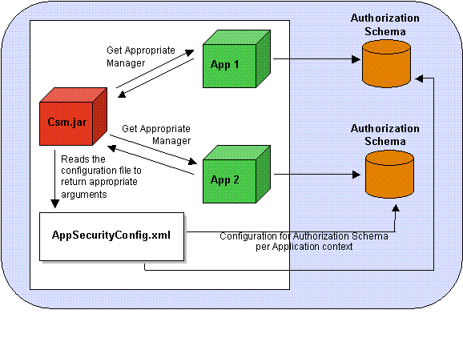
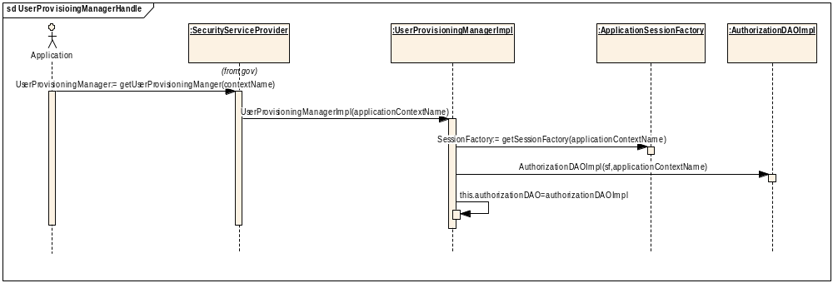

Deployment View
This section describes the physical network (hardware) configurations on which the software is deployed and run.
For the CSM first phase environment the following deployment configuration into the production environment is proposed:
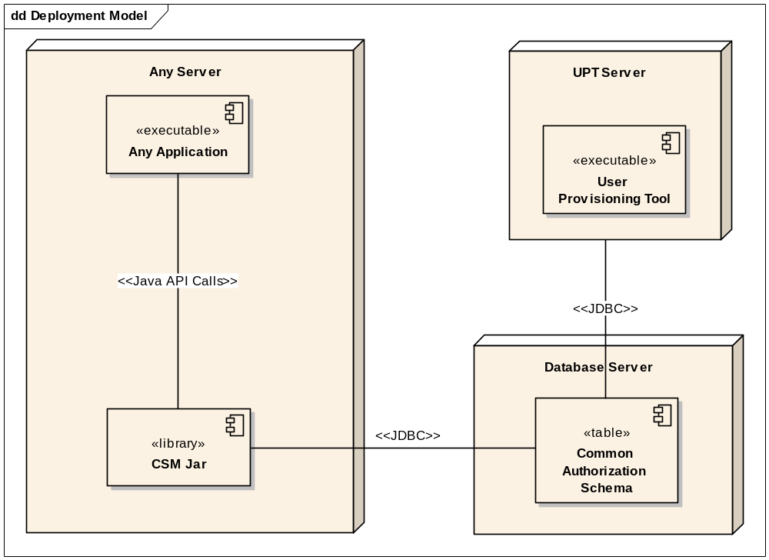

CSM system will be deployed as following:
- The CSM jar will be deployed on the same server where the application is hosted. The CSM Service will be available as a library which will be place in the class path of the application. It will run in the same container as the application and will be accessed by the making JAVA API calls.
- The User Provisioning Tool will be hosted on a separate server as a web application. The users will be able to access the application using the browsers.
- The Common Authorization Schema Database will be hosted on a database server. It could be hosted on the same database as the application or hosted on a separate database (MySQL)

Data View
Derived from Design Model below is the preliminary Data Model design.
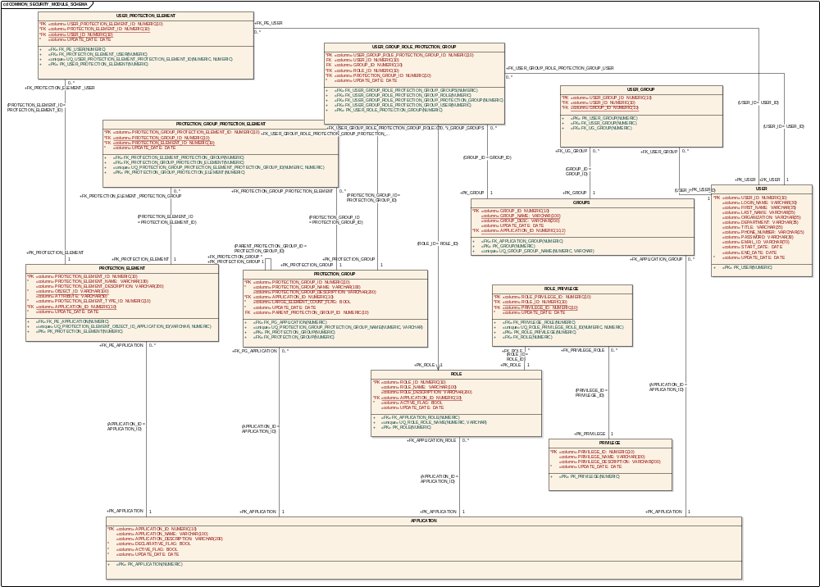

APPLICATION
Type: public «table» Class
Status: Proposed. Version 1.0. Phase 1.0.
Package: Data Model
Details: Created on 10/19/2004 4:20:30 PM. Modified on 11/23/2004 12:14:43 PM.

The application entity descibes the name of the application. The authorization context is derived from application name or application context.

Connections
- Association link from class GROUPS
- Association link from class PROTECTION_ELEMENT
- Association link from class PROTECTION_GROUP
- Association link from class ROLE

APPLICATION Attributes
Attribute | Type | Notes
APPLICATION_ID  «column» | public  (ordered) :  NUMERIC(10) | It will be a seqential number. This coulmn is the primary key for this table  Primary Key; Not Null;
APPLICATION_NAME  «column» | public :  VARCHAR(100) | Name of the application e.g caArray
APPLICATION_DESCRIPTION  «column» | public :  VARCHAR(200) | In this column description of the application may be provided.  e.g what this application does and what it pertains to.
DECLARATIVE_FLAG  «column» | public :  BOOL | To indincate if this application uses declartive security or not.  Not Null;
ACTIVE_FLAG  «column» | public :  BOOL | It shows if the application is active or not.  Not Null;
UPDATE_DATE  «column» | public :  DATE | This column will indicate the last update of the record.  Not Null;

APPLICATION Methods
Method | Type | Notes
PK_APPLICATION (NUMERIC) | «PK»  public: | param: APPLICATION_ID [ NUMERIC - in ]

GROUPS
Type: public «table» Class
Status: Proposed. Version 1.0. Phase 1.0.
Package: Data Model
Details: Created on 10/28/2004 6:18:24 PM. Modified on 11/23/2004 1:01:40 PM.

Group is a logical grouping of the users.

Connections
- Association link to class APPLICATION
- Association link from class USER_GROUP
- Association link from class USER_GROUP_ROLE_PROTECTION_GROUP

GROUPS Attributes
Attribute | Type | Notes
GROUP_ID  «column» | public  (ordered) :  NUMERIC(10) | Primary Key; Not Null;
GROUP_NAME  «column» | public static :  VARCHAR(100) | Name of the group. It should be uniqe within an application.  Unique;
GROUP_DESC  «column» | public :  VARCHAR(200) | Gives a brief decription of the group.
UPDATE_DATE  «column» | public :  DATE
APPLICATION_ID  «column» | public static :  NUMERIC(10,2) | Not Null; Unique;

GROUPS Methods
Method | Type | Notes
FK_APPLICATION_GROUP (NUMERIC) | «FK»  public: | param: APPLICATION_ID [ NUMERIC - in ]
PK_GROUP (NUMERIC) | «PK»  public: | param: GROUP_ID [ NUMERIC - in ]
UQ_GROUP_GROUP_NAME (NUMERIC, VARCHAR) | «unique»  public: | param: APPLICATION_ID [ NUMERIC - in ]  param: GROUP_NAME [ VARCHAR - in ]

PRIVILEGE
Type: public «table» Class
Status: Proposed. Version 1.0. Phase 1.0.
Package: Data Model
Details: Created on 10/20/2004 10:12:10 AM. Modified on 11/5/2004 1:27:38 PM.

This table stores the privileges. eg CRUD

Connections
- Association link from class ROLE_PRIVILEGE

PRIVILEGE Attributes
Attribute | Type | Notes
PRIVILEGE_ID  «column» | public  (ordered) :  NUMERIC(10) | primary key. It will be a sequential number.  Primary Key; Not Null;
PRIVILEGE_NAME  «column» | public :  VARCHAR(100) | Name of the privilege.  e.g Create , Read , Update or delete.
PRIVILEGE_DESCRIPTION  «column» | public :  VARCHAR(200) | a brief decription of the privilege.
UPDATE_DATE  «column» | public :  DATE | Not Null;

PRIVILEGE Methods
Method | Type | Notes
PK_PRIVILEGE (NUMERIC) | «PK»  public: | param: PRIVILEGE_ID [ NUMERIC - in ]

PROTECTION_ELEMENT
Type: public «table» Class
Status: Proposed. Version 1.0. Phase 1.0.
Package: Data Model
Details: Created on 10/19/2004 5:34:16 PM. Modified on 11/23/2004 2:53:58 PM.

Protection element is a any resource that is to be secured within an application based on roles of the user in a particular protection group context.
e.g Any object, Resource etc.

Connections
- Association link from class USER_PROTECTION_ELEMENT
- Association link from class PROTECTION_GROUP_PROTECTION_ELEMENT
- Association link to class APPLICATION

PROTECTION_ELEMENT Attributes
Attribute | Type | Notes
PROTECTION_ELEMENT_ID  «column» | public  (ordered) :  NUMERIC(10) | Primary key. It will be a sequential number.  Primary Key; Not Null;
PROTECTION_ELEMENT_NAME  «column» | public :  VARCHAR(100) | Name of the protection element. It can be any valid staring.  Not Null;
PROTECTION_ELEMENT_DESCRIPTION  «column» | public :  VARCHAR(200) | A brief description of the protection element.
OBJECT_ID  «column» | public static :  VARCHAR(100) | This can be application specific object identifier.  Not Null; Unique;
ATTRIBUTE  «column» | public :  VARCHAR(50)
PROTECTION_ELEMENT_TYPE_ID  «column» | public :  NUMERIC(10) | Not Null;
APPLICATION_ID  «column» | public static :  NUMERIC(10) | Foriegn key. Comes from the application table.  Not Null; Unique;
UPDATE_DATE  «column» | public :  DATE | Not Null;

PROTECTION_ELEMENT Methods
Method | Type | Notes
FK_PE_APPLICATION (NUMERIC) | «FK»  public: | param: APPLICATION_ID [ NUMERIC - in ]
UQ_PROTECTION_ELEMENT_OBJECT_ID_APPLICATION_ID (VARCHAR, NUMERIC) | «unique»  public: | param: OBJECT_ID [ VARCHAR - in ]  param: APPLICATION_ID [ NUMERIC - in ]
PK_PROTECTION_ELEMENT (NUMERIC) | «PK»  public: | param: PROTECTION_ELEMENT_ID [ NUMERIC - in ]

PROTECTION_GROUP
Type: public «table» Class
Status: Proposed. Version 1.0. Phase 1.0.
Package: Data Model
Details: Created on 10/19/2004 5:17:39 PM. Modified on 11/23/2004 3:07:59 PM.

Protection group is a collection of protection elements.

Connections
- Association link from class PROTECTION_GROUP
- Association link from class USER_GROUP_ROLE_PROTECTION_GROUP
- Association link from class PROTECTION_GROUP_PROTECTION_ELEMENT
- Association link to class APPLICATION

PROTECTION_GROUP Attributes
Attribute | Type | Notes
PROTECTION_GROUP_ID  «column» | public  (ordered) :  NUMERIC(10) | Primary key. It will be a seqential number.  Primary Key; Not Null;
PROTECTION_GROUP_NAME  «column» | public static :  VARCHAR(100) | Name of the protection group. It can be any valid string.  Not Null; Unique;
PROTECTION_GROUP_DESCRIPTION  «column» | public :  VARCHAR(200) | Brief decription of protection group.
APPLICATION_ID  «column» | public static :  NUMERIC(10) | Foreign key. Comes from the application table.  Not Null; Unique;
LARGE_ELEMENT_COUNT_FLAG  «column» | public :  BOOL | Not Null;
UPDATE_DATE  «column» | public :  DATE | Not Null;
PARENT_PROTECTION_GROUP_ID  «column» | public :  NUMERIC(10) | A protection group may be a child of another protection group. This requirement was very specific to CaDSR table.  A protection can only have one parent. The parent protection group can not be assigned a role and a user to it.

PROTECTION_GROUP Methods
Method | Type | Notes
FK_PG_APPLICATION (NUMERIC) | «FK»  public: | param: APPLICATION_ID [ NUMERIC - in ]
UQ_PROTECTION_GROUP_PROTECTION_GROUP_NAME (NUMERIC, VARCHAR) | «unique»  public: | param: APPLICATION_ID [ NUMERIC - in ]  param: PROTECTION_GROUP_NAME [ VARCHAR - in ]
PK_PROTECTION_GROUP (NUMERIC) | «PK»  public: | param: PROTECTION_GROUP_ID [ NUMERIC - in ]
FK_PROTECTION_GROUP (NUMERIC) | «FK»  public: | param: PARENT_PROTECTION_GROUP_ID [ NUMERIC - in ]

PROTECTION_GROUP_PROTECTION_ELEMENT
Type: public «table» Class
Status: Proposed. Version 1.0. Phase 1.0.
Package: Data Model
Details: Created on 10/19/2004 5:38:31 PM. Modified on 11/23/2004 2:55:52 PM.

Establishes the relationship between protection groups and protection elements. Using this one can find out the protection elements belonging to a protection group or vice versa.

Connections
- Association link to class PROTECTION_GROUP
- Association link to class PROTECTION_ELEMENT

PROTECTION_GROUP_PROTECTION_ELEMENT Attributes
Attribute | Type | Notes
PROTECTION_GROUP_PROTECTION_ELEMENT_ID  «column» | public  (ordered) :  NUMERIC(10) | Primary key. It will be a sequential number.  Primary Key; Not Null;
PROTECTION_GROUP_ID  «column» | public static :  NUMERIC(10) | Foriegn key. Comes from protection group table.  Not Null; Unique;
PROTECTION_ELEMENT_ID  «column» | public static :  NUMERIC(10) | Foreign key. Comes from protection element table.  Not Null; Unique;
UPDATE_DATE  «column» | public :  DATE | Not Null;

PROTECTION_GROUP_PROTECTION_ELEMENT Methods
Method | Type | Notes
FK_PROTECTION_ELEMENT_PROTECTION_GROUP (NUMERIC) | «FK»  public: | param: PROTECTION_ELEMENT_ID [ NUMERIC - in ]
FK_PROTECTION_GROUP_PROTECTION_ELEMENT (NUMERIC) | «FK»  public: | param: PROTECTION_GROUP_ID [ NUMERIC - in ]
UQ_PROTECTION_GROUP_PROTECTION_ELEMENT_PROTECTION_GROUP_ID (NUMERIC, NUMERIC) | «unique»  public: | param: PROTECTION_ELEMENT_ID [ NUMERIC - in ]  param: PROTECTION_GROUP_ID [ NUMERIC - in ]
PK_PROTECTION_GROUP_PROTECTION_ELEMENT (NUMERIC) | «PK»  public: | param: PROTECTION_GROUP_PROTECTION_ELEMENT_ID [ NUMERIC - in ]

ROLE
Type: public «table» Class
Status: Proposed. Version 1.0. Phase 1.0.
Package: Data Model
Details: Created on 10/19/2004 4:21:26 PM. Modified on 11/23/2004 3:49:52 PM.

This entity defines the roles associated with an application.

Connections
- Association link from class USER_GROUP_ROLE_PROTECTION_GROUP
- Association link from class ROLE_PRIVILEGE
- Association link to class APPLICATION

ROLE Attributes
Attribute | Type | Notes
ROLE_ID  «column» | public  (ordered) :  NUMERIC(10) | This column is a primary key and may be a seqential number.  Primary Key; Not Null;
ROLE_NAME  «column» | public static :  VARCHAR(100) | Name of the role. It should be unique.  Unique;
ROLE_DESCRIPTION  «column» | public :  VARCHAR(200) | description of the role  e.g " This role can do this or that"
APPLICATION_ID  «column» | public static :  NUMERIC(10) | It is a foreign key coming for application table  Not Null; Unique;
ACTIVE_FLAG  «column» | public :  BOOL | indicates if the role is active or not.  Not Null;
UPDATE_DATE  «column» | public :  DATE | indicates the last update date of the record

ROLE Methods
Method | Type | Notes
FK_APPLICATION_ROLE (NUMERIC) | «FK»  public: | param: APPLICATION_ID [ NUMERIC - in ]
UQ_ROLE_ROLE_NAME (NUMERIC, VARCHAR) | «unique»  public: | param: APPLICATION_ID [ NUMERIC - in ]  param: ROLE_NAME [ VARCHAR - in ]
PK_ROLE (NUMERIC) | «PK»  public: | param: ROLE_ID [ NUMERIC - in ]

ROLE_PRIVILEGE
Type: public «table» Class
Status: Proposed. Version 1.0. Phase 1.0.
Package: Data Model
Details: Created on 10/20/2004 10:22:18 AM. Modified on 11/23/2004 2:51:43 PM.

This table stores the relationship between roles and privileges. Using this table one can find out the associated privileges with any role.

Connections
- Association link to class PRIVILEGE
- Association link to class ROLE

ROLE_PRIVILEGE Attributes
Attribute | Type | Notes
ROLE_PRIVILEGE_ID  «column» | public  (ordered) :  NUMERIC(10) | Primary key. Any sequential number  Primary Key; Not Null;
ROLE_ID  «column» | public static :  NUMERIC(10) | Foreign key coming from role table.  Not Null; Unique;
PRIVILEGE_ID  «column» | public static :  NUMERIC(10) | Foreign key coming from privilege table.  Not Null; Unique;
UPDATE_DATE  «column» | public :  DATE | Indicates the last update date for the record.  Not Null;

ROLE_PRIVILEGE Methods
Method | Type | Notes
FK_PRIVILEGE_ROLE (NUMERIC) | «FK»  public: | param: PRIVILEGE_ID [ NUMERIC - in ]
UQ_ROLE_PRIVILEGE_ROLE_ID (NUMERIC, NUMERIC) | «unique»  public: | param: PRIVILEGE_ID [ NUMERIC - in ]  param: ROLE_ID [ NUMERIC - in ]
PK_ROLE_PRIVILEGE (NUMERIC) | «PK»  public: | param: ROLE_PRIVILEGE_ID [ NUMERIC - in ]
FK_ROLE (NUMERIC) | «FK»  public: | param: ROLE_ID [ NUMERIC - in ]  Foreign key constraint

USER
Type: public «table» Class
Status: Proposed. Version 1.0. Phase 1.0.
Package: Data Model
Details: Created on 10/19/2004 4:16:29 PM. Modified on 11/23/2004 1:03:20 PM.

Stores the users of the application.

Connections
- Association link from class USER_GROUP
- Association link from class USER_PROTECTION_ELEMENT
- Association link from class USER_GROUP_ROLE_PROTECTION_GROUP

USER Attributes
Attribute | Type | Notes
USER_ID  «column» | public  (ordered) :  NUMERIC(10) | Primary Key; Not Null;
LOGIN_NAME  «column» | public :  VARCHAR(30) | This value is used to login into the application.  e.g jhd334
FIRST_NAME  «column» | public :  VARCHAR(35) | First name of the user.
LAST_NAME  «column» | public :  VARCHAR(35) | Last name of the user.
ORGANIZATION  «column» | public :  VARCHAR(35) | which organization does he belong to.
DEPARTMENT  «column» | public :  VARCHAR(35) | Department a user belongs to.
TITLE  «column» | public :  VARCHAR(35) | What is the title of this user?
PHONE_NUMBER  «column» | public :  VARCHAR(15) | Phone number of the user. It is stored just as a string.
PASSWORD  «column» | public :  VARCHAR(30) | The password for login.
EMAIL_ID  «column» | public :  VARCHAR(70) | email id of the user.
START_DATE  «column» | public :  DATE
END_DATE  «column» | public :  DATE
UPDATE_DATE  «column» | public :  DATE | Not Null;

USER Methods
Method | Type | Notes
PK_USER (NUMERIC) | «PK»  public: | param: USER_ID [ NUMERIC - in ]

USER_GROUP
Type: public «table» Class
Status: Proposed. Version 1.0. Phase 1.0.
Package: Data Model
Details: Created on 10/28/2004 6:25:22 PM. Modified on 11/23/2004 2:41:52 PM.

Establishes the relationship between users and group. Using this table one can find out the users for a group or groups for a user.

Connections
- Association link to class GROUPS
- Association link to class USER

USER_GROUP Attributes
Attribute | Type | Notes
USER_GROUP_ID  «column» | public  (ordered) :  NUMERIC(10) | Primary key. It will be a sequential number.  Primary Key; Not Null;
USER_ID  «column» | public static :  NUMERIC(10) | Forign key and comes from user table.  Not Null; Unique;
GROUP_ID  «column» | public static :  NUMERIC(10) | Foriegn key and comes from group table.  Not Null; Unique;

USER_GROUP Methods
Method | Type | Notes
PK_USER_GROUP (NUMERIC) | «PK»  public: | param: USER_GROUP_ID [ NUMERIC - in ]
FK_USER_GROUP (NUMERIC) | «FK»  public: | param: USER_ID [ NUMERIC - in ]
FK_UG_GROUP (NUMERIC) | «FK»  public: | param: GROUP_ID [ NUMERIC - in ]

USER_GROUP_ROLE_PROTECTION_GROUP
Type: public «table» Class
Status: Proposed. Version 1.0. Phase 1.0.
Package: Data Model
Details: Created on 10/20/2004 10:43:09 AM. Modified on 11/23/2004 3:41:05 PM.

This table establishes the relation between protection group, user, role and group.
A user is assigned a role for a particular protection group.
Or
A a group is assigned a role for a particular protection group. This way a context of the protection group is set here for a role assumed by a user or a group.

Connections
- Association link to class ROLE
- Association link to class PROTECTION_GROUP
- Association link to class GROUPS
- Association link to class USER

USER_GROUP_ROLE_PROTECTION_GROUP Attributes
Attribute | Type | Notes
USER_GROUP_ROLE_PROTECTION_GROUP_ID  «column» | public  (ordered) :  NUMERIC(10) | Primary key. It will be a seqential number.  Primary Key; Not Null;
USER_ID  «column» | public :  NUMERIC(10) | Foreign key. Comes from user table.
GROUP_ID  «column» | public :  NUMERIC(10) | Foreign key. Comes from group table.
ROLE_ID  «column» | public :  NUMERIC(10) | Foreign key and comes from role table.  Not Null;
PROTECTION_GROUP_ID  «column» | public :  NUMERIC(10) | Foreign key and comes from protection group.  Not Null;
UPDATE_DATE  «column» | public :  DATE | Not Null;

USER_GROUP_ROLE_PROTECTION_GROUP Methods
Method | Type | Notes
FK_USER_GROUP_ROLE_PROTECTION_GROUP_GROUPS (NUMERIC) | «FK»  public: | param: GROUP_ID [ NUMERIC - in ]
FK_USER_GROUP_ROLE_PROTECTION_GROUP_ROLE (NUMERIC) | «FK»  public: | param: ROLE_ID [ NUMERIC - in ]
FK_USER_GROUP_ROLE_PROTECTION_GROUP_PROTECTION_GROUP (NUMERIC) | «FK»  public: | param: PROTECTION_GROUP_ID [ NUMERIC - in ]
FK_USER_GROUP_ROLE_PROTECTION_GROUP_USER (NUMERIC) | «FK»  public: | param: USER_ID [ NUMERIC - in ]
PK_USER_ROLE_PROTECTION_GROUP (NUMERIC) | «PK»  public: | param: USER_GROUP_ROLE_PROTECTION_GROUP_ID [ NUMERIC - in ]

USER_PROTECTION_ELEMENT
Type: public «table» Class
Status: Proposed. Version 1.0. Phase 1.0.
Package: Data Model
Details: Created on 10/20/2004 1:33:11 PM. Modified on 11/23/2004 2:54:52 PM.

This table established the relationship between users and protection elements stating them as owner of that protection element.

Connections
- Association link to class USER
- Association link to class PROTECTION_ELEMENT

USER_PROTECTION_ELEMENT Attributes
Attribute | Type | Notes
USER_PROTECTION_ELEMENT_ID  «column» | public  (ordered) :  NUMERIC(10) | Primary key. It will be a sequential number.  Primary Key; Not Null;
PROTECTION_ELEMENT_ID  «column» | public static :  NUMERIC(10) | Foreign key. Comes from the protection element table.  Not Null; Unique;
USER_ID  «column» | public static :  NUMERIC(10) | Foreign key. Comes from user table.  Not Null; Unique;
UPDATE_DATE  «column» | public :  DATE | Not Null;

USER_PROTECTION_ELEMENT Methods
Method | Type | Notes
FK_PE_USER (NUMERIC) | «FK»  public: | param: USER_ID [ NUMERIC - in ]
FK_PROTECTION_ELEMENT_USER (NUMERIC) | «FK»  public: | param: PROTECTION_ELEMENT_ID [ NUMERIC - in ]
UQ_USER_PROTECTION_ELEMENT_PROTECTION_ELEMENT_ID (NUMERIC, NUMERIC) | «unique»  public: | param: USER_ID [ NUMERIC - in ]  param: PROTECTION_ELEMENT_ID [ NUMERIC - in ]
PK_USER_PROTECTION_ELEMENT (NUMERIC) | «PK»  public: | param: USER_PROTECTION_ELEMENT_ID [ NUMERIC - in ]

Technology Stack
The following technologies will be used to develop the product
  - JDK1.4.x
  - JBOSS 3.2.x
  - Hibernate 2.6
  - MYSQL 4.11
  - Enterprise Architect for modeling
  - Struts and tile for web application

